1.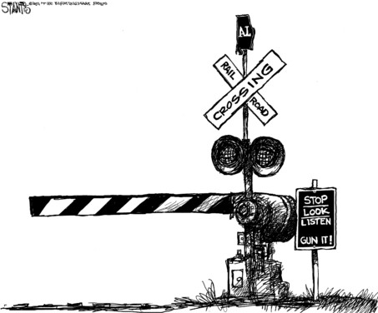

With lights to blink, speaker to beep, gate to move, and all with different time constraints, the train crossing is a fairly complex problem if taken as a whole, and can be intimidating. In fact, it is actually impossible to do properly with a single processor. However, the job can be done with properly coordinated multiple processors.

We will use the divide and conquer method. That is a plan of attack where you repeatedly break down the problem into two or more sub-problems until these become simple enough to be solved directly. The solutions to the sub-problems are then combined to give a solution to the original problem.

LOGIC of the Train Crossing:
The system needs to know two things:
Is a train present? What is the current state of the system?
Two state variables: trainPresent (1 = yes, 0=no) active (1=yes, 0=no)

What are the rules?
If a train is present and the system is not active, then make the system active.
If no train is present and the system is active, make the system inactive.
Note: only TWO of the possible four states require action. If the train is present and the system is active, or if the train is not present and the system is not active then no action is required.

Initialization: active =0
start infinite loop:
is train present AND system inactive ?
yes : set state to active; start lights; start beeps; move gate down
no: do nothing
is system active and no train present
yes: set state to inactive; stop lights; stop beeps; move gate up
no: do nothing
end of infinite loop

2. 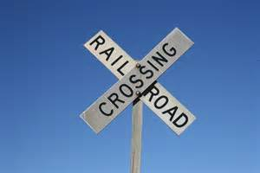
/*
Outline of train crossing -- incomplete but all logic seems right
RWH Dec 04, 2014
*/
#include "simpletools.h" // Include simple tools

//global variables
int *b; //pointer variable for beeper cog
int *f; //pointer variable for flasher cog
int active =0; // indicates the current state of the system 1=active 0=not active

void flasher()
{while(1){high(26); pause(200); low(26); pause(200); }} //end flasher

void beeper()
{while(1){high(27);pause(500);low(27); pause(500);}} //end beeper
// functions to move the gate need to be provided here.
int main()
{
while(1)
{
int trainPresent = input(6); //check if the train is present - button connected to pin 6
if(trainPresent & !active) //if train is present and the system is not active
{
active = 1; //note that the system is now active
f = cog_run(&flasher,20); // start the flasher in another cog
b = cog_run(&beeper,20);
} // now the system is active

else if(!trainPresent & active) //system is active, but train is gone
{
active=0; //note that the system is now inactive
cog_end(b); // stop the beeper
cog_end(f);
}// now the system is resting and waiting for another train
}// end of infinite loop
}//end main

