Name _______________________________________________________ V 2.0
SONY REMOTE PROJECT:
- Follow the instructions to program your remote with the SONY code “605”
- Wire up the IR detector according to the following schematic. _____________________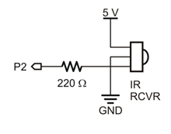
- Have the instructor check your wiring and initial here: _______________ so that you don’t burn anything out.
- Create and run the following BLOCKLY PROP Program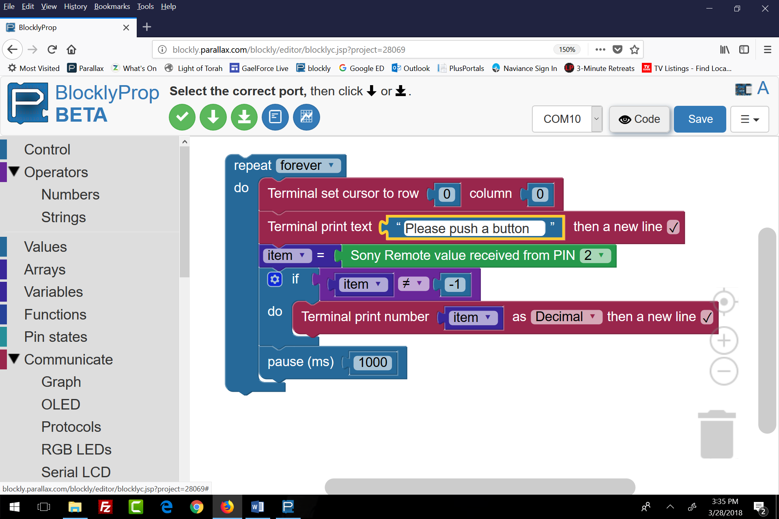
- Then you run the program and push a button on the remote, each button on the remote should produce a unique number. You need to detect the number and assign some action to it later in your program. In order to do that, you need to make yourself a chart so that you know what number is associated with each remote key. Create a chart like the following:
Button Pushed | Number returned | Action Triggered
Power
1
2
3
4
5
6
7
8
9
0
Chanel up
Chanel down
Volume>
Volume<
Mute
Then decide what action (forward, back, stop, right, left, beep, set a fire, explode!, etc.) to associate with each button. Have the instructor check your wiring and initial here: _______________
- There are several ways to proceed from here. You are already familiar with the IF …DO construction, so you could use that or the SWITCH…CASE construction to control your robot.
- The outline which follows should help you get started.
Now that it is working, what do you want to do with it?
- Demonstrate that you can guide the robot using the Remote and submit an essay on how it works and print out a listing of the programs with copious comments.
- Add a green LED to the robot and have the green Led on whenever the robot is moving forward. The green light should go off when the robot is standing still, moving backward, or moving any direction except forward. Demonstrate that all that works as required and submit an essay on how it works and a listing of the programs with copious comments.
- Have the robot beep intermittently whenever it is moving in reverse. (It might be necessary to write a function to do this and run the function in another cog). Demonstrate that all that works as required and submit an essay on how it works and a listing of the programs with copious comments.
- Do something creative. Demonstrate your creative addition and submit an essay on how it works and a listing of the programs with copious comments.
Note:
If other groups are working with the Sony Remote it is possible that your robot will pick up their signals and vice-versa. If you agree to have each group use a different subset of remote buttons that will reduce the problem.

How to program the Sony Remote:
1. Press and hold the “Set-Up” button until the red light stays on.
2. Press 605 on the keypad.
3. The red light will go off, indicating that the remote has been programmed.
4. You MUST program the remote any time you replace the battery.

