PATH 2 (revised 11/24/21)
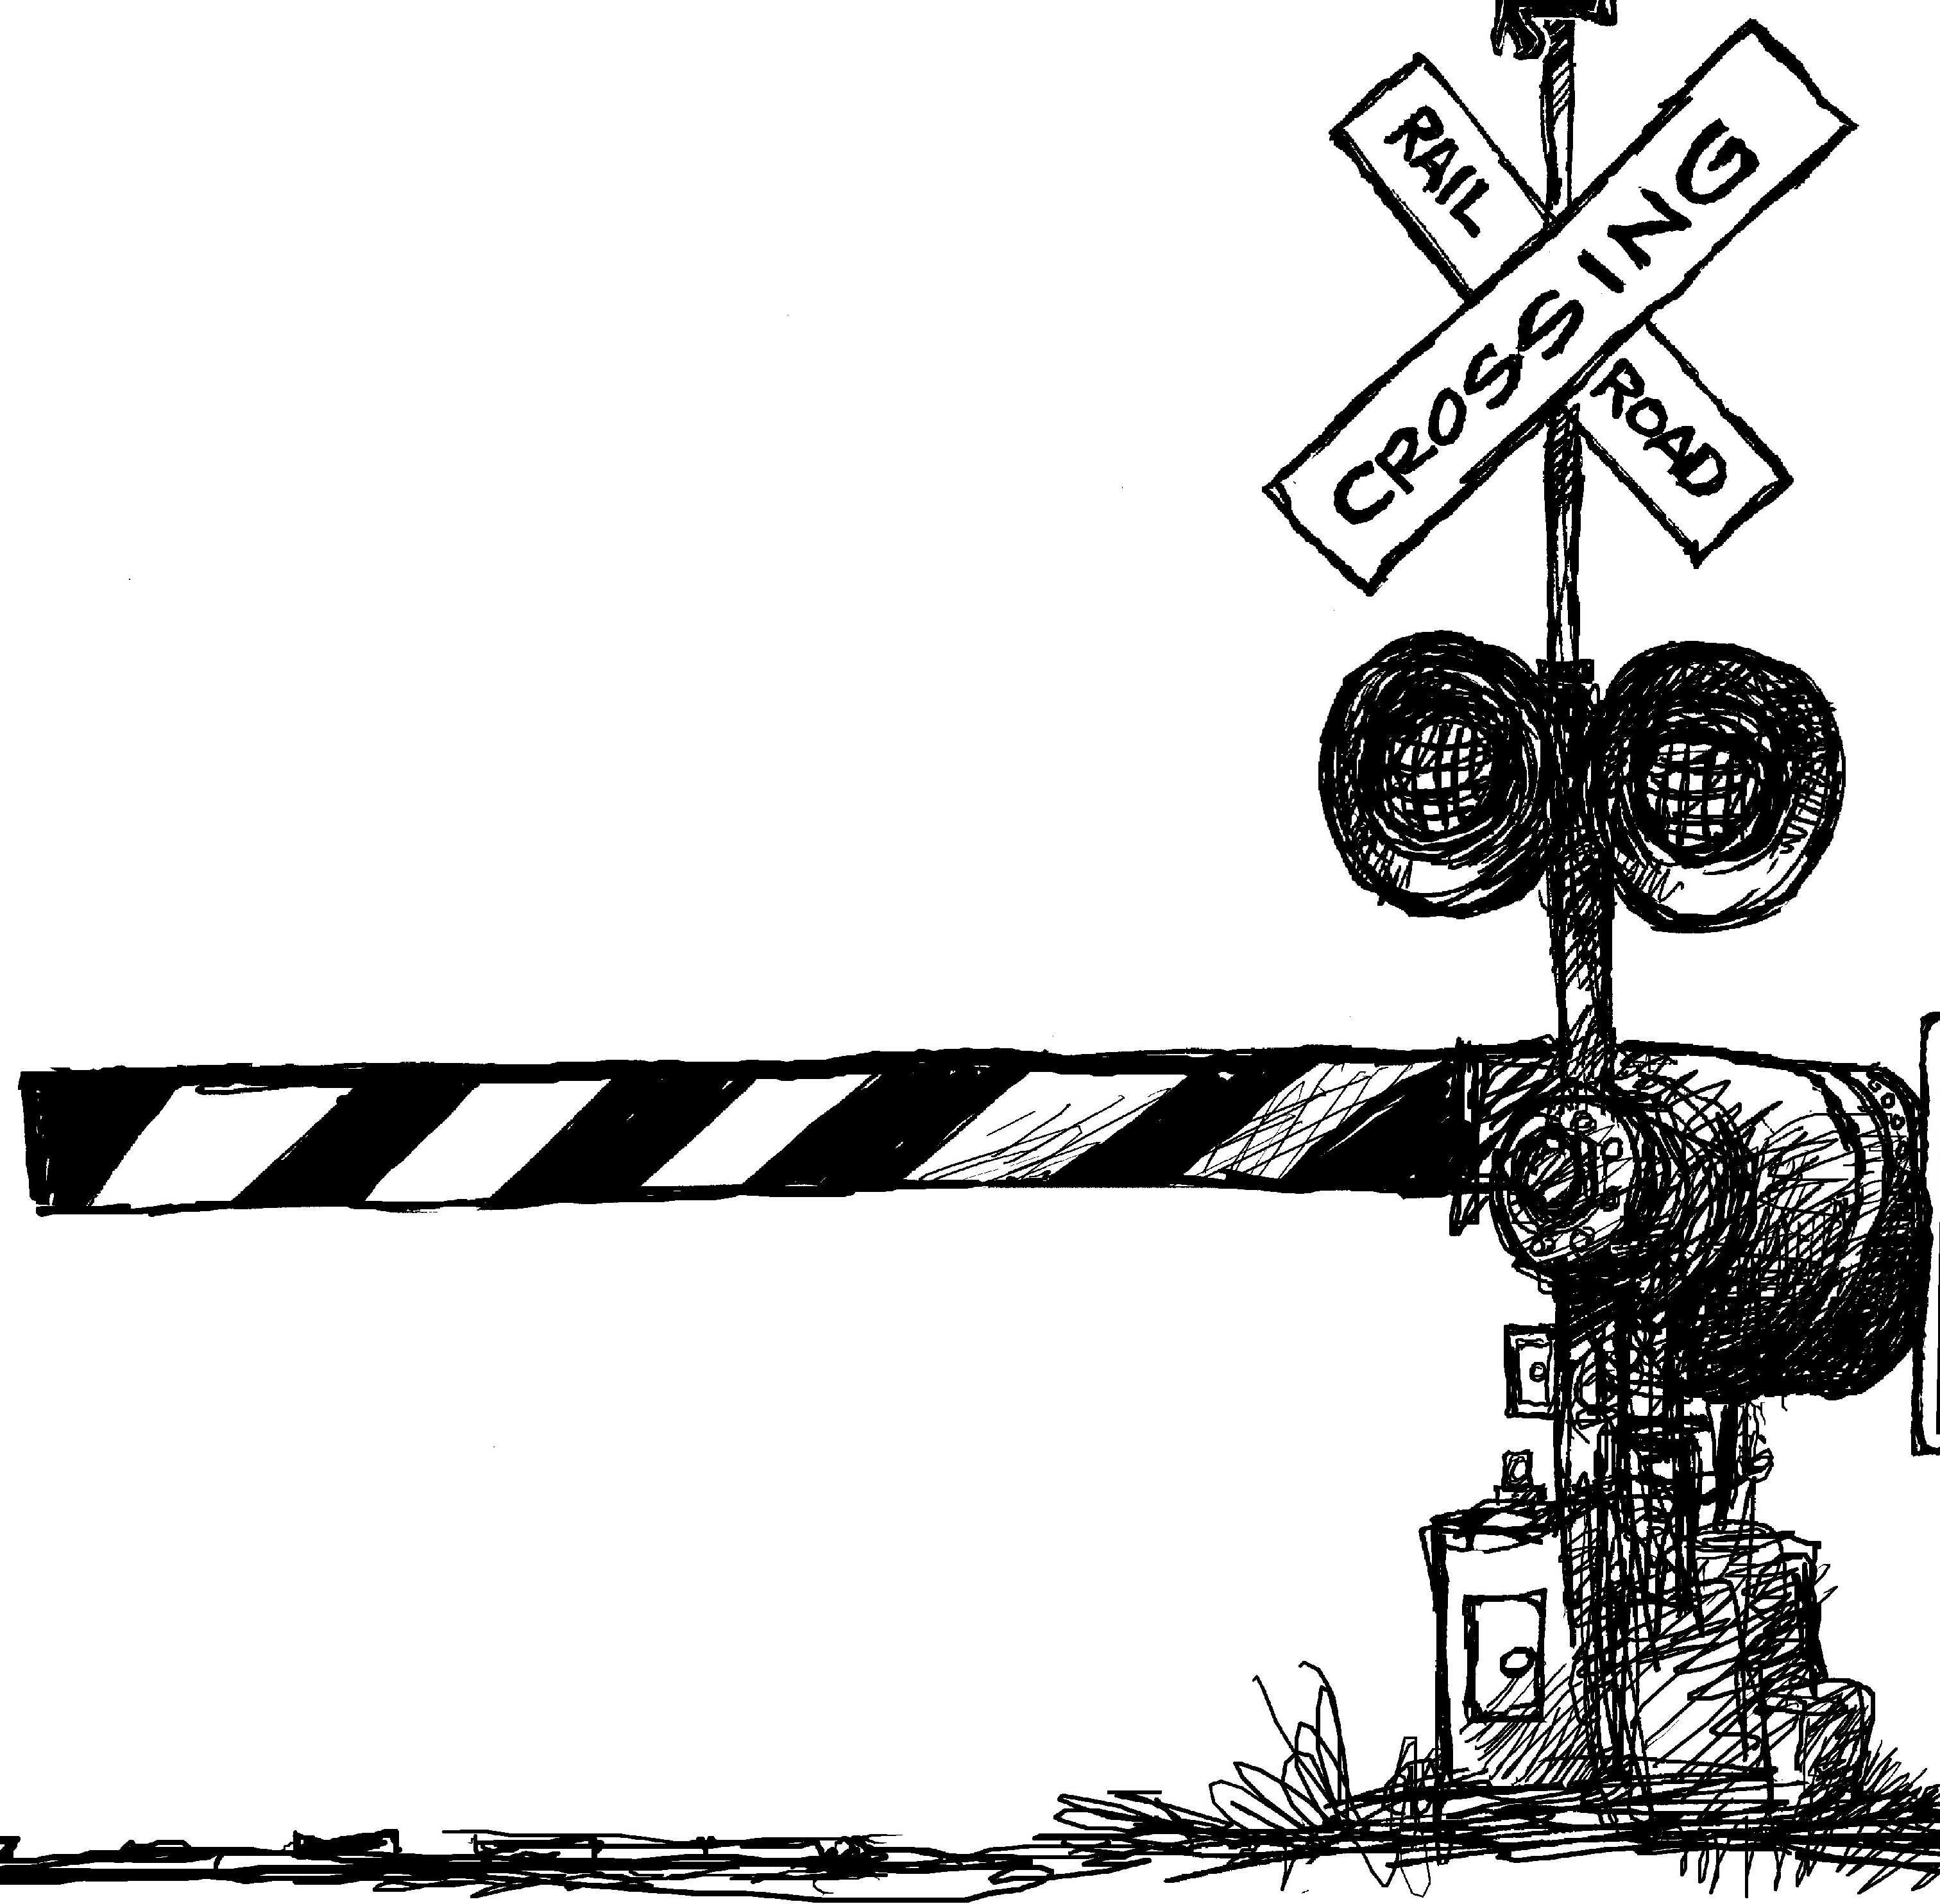
Engineering problem: The Railroad Crossing.
1. Watch this video and note that there are three things operating at an automated railroad grade crossing: sound, lights, and gate.
https://www.youtube.com/watch?v=cIVU64iswUM

You should have seen that the lights and sound start first. They operate on different cycle times, the sounds cycling on and off at a higher frequency than the flashing of the lights. After a brief delay the gate starts coming down.
After the train has completely passed the crossing the gates begin to move up. There is a slight delay before the sounds and flashing lights stop.
So, this is your next project: MODEL A TRAIN CROSSING
Input:
- Use a pushbutton to indicate the approach of the train.
- You will hold the button down for as long as the train is present.
Output:
- LEDs on pins 26 and 27 flash alternately at a frequency of 1 Hz beginning when the button is first pushed.
- The beeper beeps with a 50% duty cycle 2 times each second beginning when the button is first pushed.
- The gate begins to descend 5 seconds after the button is pushed.
- The gate begins to go up as soon as the button is released.
- The red LEDs and the beeper stop 5 seconds after the button is released.

Build the necessary circuits and program your microcontroller to operate a grade crossing.

This link shows a different way of managing a grade crossing. What are the advantages and disadvantages of this approach? https://www.youtube.com/watch?v=jnN7oPLIkuI
Additional Information:
These are actual numbers taken from the newspaper after a bad crossing accident:
- Lights start to flash at least 20 seconds before the train arrives.
- Lights must flash for at least three seconds before the gates start to come down.
- Gates must be horizontal for at least five seconds before the train arrives.
- New York law mandates that drivers stop at least 15 feet from the nearest rail.
- If traffic is bad you should never enter the track area unless there is room ahead to clear it.
- Never drive around lowered gates.
- If you find yourself caught between the gates, stay in your car and barrel through the gates, which are made of fiberglass and designed to break off when hit.
- Run at a 45 degree angle in the direction of the train, away from the crossing.

