Joystick Controlled Activity Bot
Go to https://learn.parallax.com/tutorials/projects/joystick-controlled-activitybot
Follow the instructions to build the controller and also to set up the XBEE on the Activity Bot.
The program given there is in C, which you can use if you have Simple IDE installed.
However, if you want to use BlocklyProp you may use what follows as a guide:
For the transmitter:
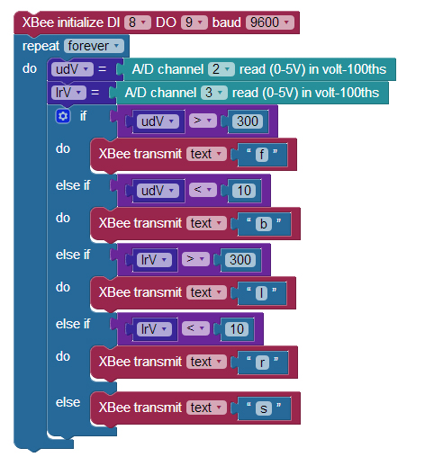
You can compare this to the C program listed in the Parallax site. It follows directly. First it initializes the XBee device, then it goes into an infinite loop. It reads the udV (up/down Voltage) and the lrV (left/right) voltage from the A/D channels and then, depending upon the voltages, it transmits a single letter f(orward), b(ack), l(eft), r(ight), or s(top) to the receiver.

The receiver takes the letter and issues Robot drive speed commands. Only the first part of the program is given. You should be able to figure out the rest.

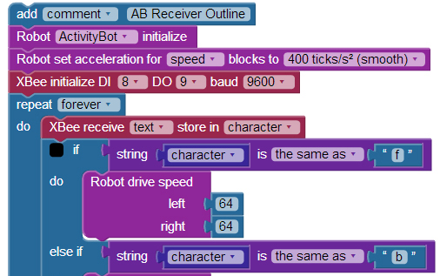
IMPORTANT:
If other students are doing a similar project their receiver may pick up your transmitter, and vice versa. To prevent that, you may simply use different letters in both the transmission and reception.

Now that it is working, what do you want to do with it?
- Demonstrate that you can guide the robot using the joystick and submit an essay on how it works and print out a listing of the two programs (receiver and transmitter) with copious comments.
- Add a green LED to the robot and have the green Led on whenever the robot is moving forward. The green light should go off when the robot is standing still, moving backward, or moving any direction except forward.
- Have the robot beep intermittently whenever it is moving in reverse. (It might be necessary to write a function to do this and run the function in another cog).
- Demonstrate that all that works as required and submit an essay on how it works and a listing of the two programs (transmitter and receiver) with copious comments.
- Do something creative
- Demonstrate your creative addition and submit an essay on how it works and a listing of the two programs (transmitter and receiver) with copious comments.

