Fingerprint Scanner help V 1.2 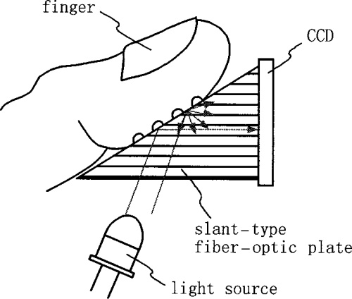

You must determine what you actually want the fingerprint scanner to control and how that will be accomplished. Obviously, the scanner will only provide an electrical signal as output. You will use the signal to control whatever you want to the entire project to do.

- Follow the link below to learn now to set up and use the fingerprint scanner. That will get you started.
https://learn.parallax.com/print/book/export/html/1642 It is VERY IMPORTANT that you get the wiring right. It is possible to burn out the device! Have the instructor check your wiring before turning on the power. Instructor’s initials here: ______________________________________
- Experiment with the device. Be sure you understand how it works. You should add your own fingerprints and have them recognized. Demonstrate that to your instructor. Instructor’s initials here __________________________
- After that you can proceed to add your own custom programming as well as the electronic and mechanical parts which are needed to complete your project.
- This link will give you more information about how biometrics in general and fingerprint scanners in particular: http://www.explainthatstuff.com/fingerprintscanners.html
- If you want more detailed technical information about the scanner, follow the link below (You probably will not need to access this manual which contains really detailed technical information. However, you might be interested in seeing what data is available to electronic engineers who are designing custom products.) https://www.parallax.com/sites/default/files/downloads/29126-UART-Fingerprint-Reader-UserManual.pdf

