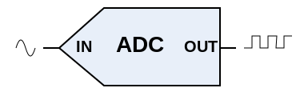
Analog to digital conversion:
Analog-to-digital conversion is the process which is performed by an analog-to-digital converter (ADC, A/D, A to D, A2D). It converts a continuous physical quantity (voltage, current, location) to a digital number that represents the amplitude of the quantity.
The conversion always introduces a small amount of error. The ADC will usually “sample” the variable at small time intervals, produce a number representing its magnitude, and then take another sample.
An ADC is defined by its bandwidth (the range of frequencies it can measure) and its signal to noise ratio (how accurately it can measure a signal relative to the noise it introduces).
The inverse operation (Digital to Analog) is performed by a digital-to-analog converter (DAC).
The Activity Board has a 12-bit 4-channel SPI ADC. That means it can accept a signal between 0 and +5 volts and convert it to a 12 bit digital number. (See the TI Spec sheet for the ADC124S021.)
BlocklyProp has two blocks, The first one reads an analog channel and the second supplies an analog channel. They are located in the analog section.
