Traffic Signal triggered by a Sensor
Preparation:
Go through the tutorial page located at:
http://learn.parallax.com/propeller-c-simple-circuits/check-pushbuttons
and view the video located at:
https://www.youtube.com/watch?v=BxA7qwmY9mg
While doing that add the following to your notebook:
Vocabulary:
active high pushbutton (definition and schematic diagram)
active low pushbutton (definition and schematic diagram)
pull up resistor
pull down resistor
C functions:
high()
low()
pause()
input()
print()
Statements:
if ()
if() else

Performance Test 4
The traffic signal which is located at Iona’s entrance turns on the green facing Wilmot Road and the red facing Iona Prep. It stays that way until a sensor in the road indicates a car is waiting at Iona Prep. That triggers the timing diagram below. (A) Wilmot facing lights (B) Iona facing lights.

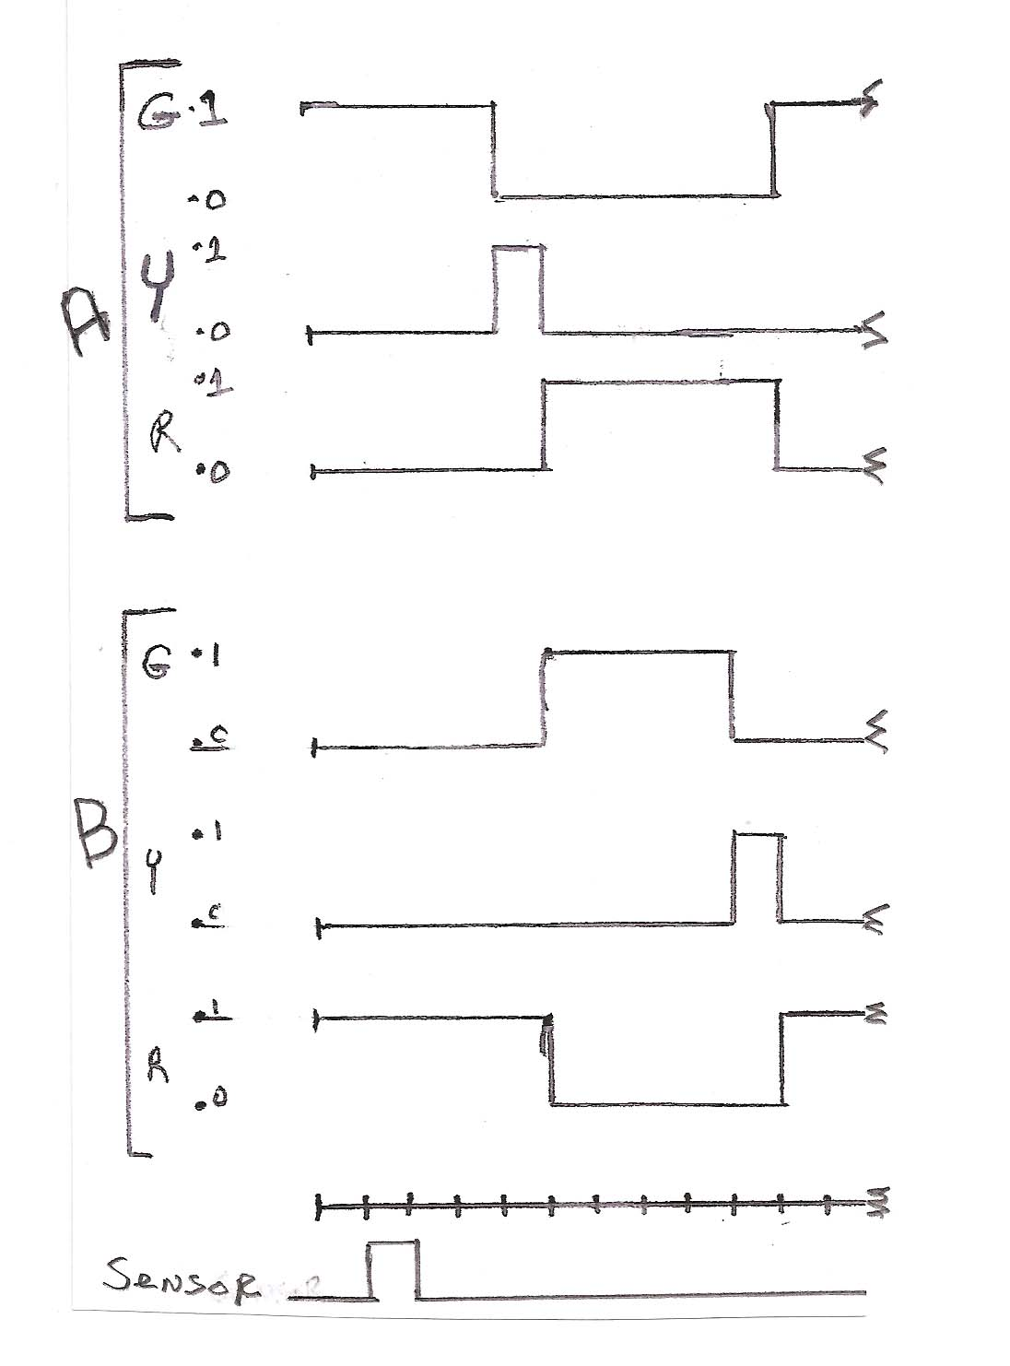
(Note: There is a 2 second delay between the arrival of the sensor pulse and the Green to yellow transition of the Wilmot set of lights.) After the cycle has been completed, the controller leaves Wilmot green and Iona red until a new cycle is triggered by the sensor. At this point you need not worry about what happens if a sensor pulse arrives during the actual cycle.

Assignment:
1. Draw the schematic diagram.
2. Construct and program the circuit.
3. Demonstrate the circuit to your teacher.
4. Hand in the Schematic and program (Remember: Lots of comments and “Presentation quality”!)

