Name ____________________________________________ Date completed:_____________
Performance test 3:
Create a full traffic signal:
(1) There is one set of red, yellow, and green for one direction (A) and another set for the other direction (B).
(2) They operate according to the following timing diagram and cycle forever
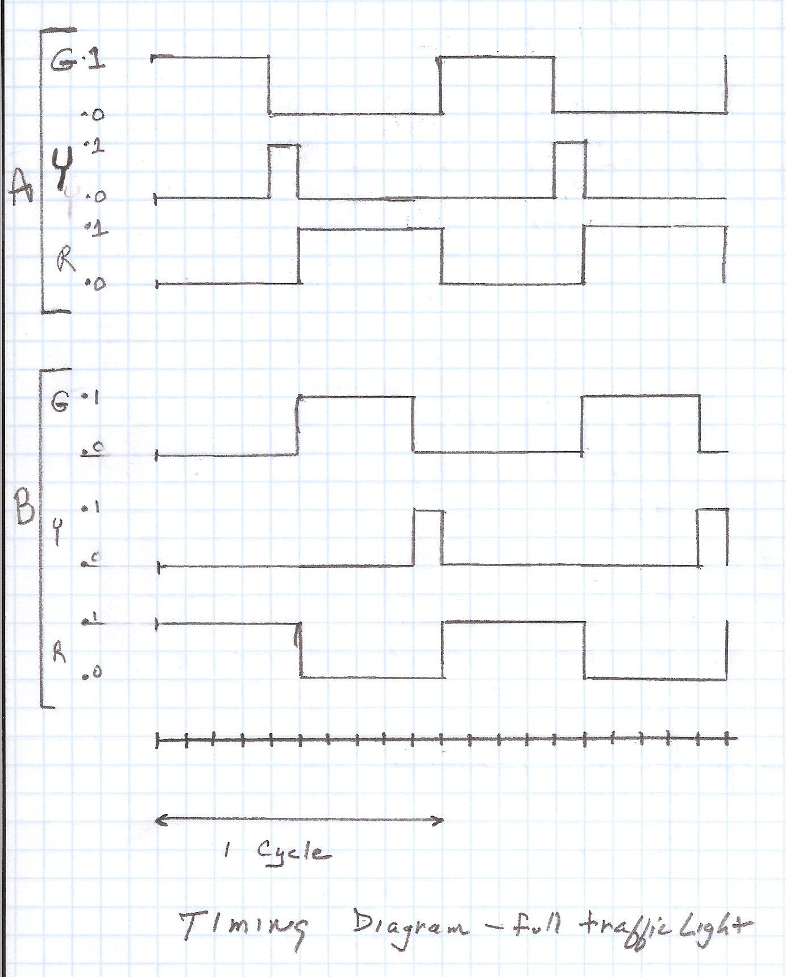.

You must do the following:
- Demonstrate a working version
- Hand in a printed copy of the program with copious comments
- Include the appropriate schematic diagram

