Name __________________________________________________________

Performance Test 1:
You want to make a Traffic control (one red and one green light) which operates according to the following diagram:
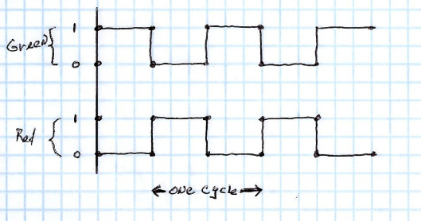
Assumptions:
1. One cycle is 6 seconds. – Obviously it should be longer, but this makes your debugging time easier.
2. The light cycles forever.
Print out the final version of the program and provide a proper schematic diagram.

Performance Test 2:
Twice as much work:
Add two more lights (for the opposite direction). Change the programming so that when one direction has green, the other has red.
Print out the final version of the program and provide a proper schematic diagram.

