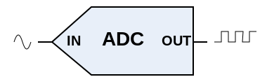
Analog to digital conversion:
Analog-to-digital conversion is the process which is performed by an analog-to-digital converter (ADC, A/D, A to D, A2D). It converts a continuous physical quantity (voltage, current, location) to a digital number that represents the amplitude of the quantity.
The conversion always introduces a small amount of error. The ADC will usually “sample” the variable at small time intervals, produce a number representing its magnitude, and then take another sample.
An ADC is defined by its bandwidth (the range of frequencies it can measure) and its signal to noise ratio (how accurately it can measure a signal relative to the noise it introduces).
The inverse operation (Digital to Analog) is performed by a digital-to-analog converter (DAC).
The Activity Board has a 12-bit 4-channel SPI ADC. That means it can accept a signal between 0 and +5 volts and convert it to a 12 bit digital number. (See the TI Spec sheet for the ADC124S021.)
Using the ADC on the Activity Board requires several steps:
(1) Include the library of functions already developed for the ADC
#include "adcDCpropab.h"
(2) Set certain variables
adc_init(21, 20, 19, 18); // CS=21, SCL=20, DO=19, DI=18
(3) declare a floating variable to hold the reading
float voltage;
(4) read the ADC and store the reading in your variable
voltage = adc_volts(3); // you are reading channel 3

