Electronics and Robotics
An amazing project
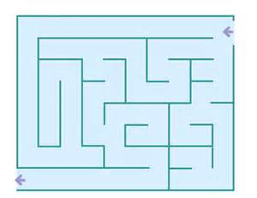
The last two projects were examples of dead reckoning. In both cases you used a closed loop approach with feedback to make the wheels go a reasonably correct distance. However, there was no feedback to the system about where the robot was actually located. Errors could creep in because of slippage between the wheels and the floor, and for other reasons. Errors could accumulate, making the final position less than perfect. Therefore, though the wheel rotation control was part of a closed loop system, there was no feedback of the actual position, making that part of the system an open loop.
It might be possible to navigate a previously known maze using such an open loop approach. However, if the dimensions of the maze were to change in any way then the programming would have to be adjusted in order to accommodate that change.
In order to navigate an unknown maze you really need a feedback loop to check for and adjust to obstructions. That kind of program could automatically adjust to changes in the maze.
Next project:
You will navigate a maze using ONE of the following methods: (A) Touch using whiskers (B)Ultrasound using a Ping sensor (C) Sight using Infrared headlights.
1. The group will decide which method to use. In order to do that you will be given 1 class period to investigate the three methods and decide which method is your first choice and which is your second choice. (No more than 4 groups will be permitted to use the same method.) You will write a 1 page essay stating your choice, how it works, and the reason that you made that choice. You will print out your essay and hand it in at the beginning of the next class period. The teacher will decide which method each group will use.
2. You will spend several class periods constructing, programming, and testing your robot. During this time the partners should share the work equally and both partners should have a good working knowledge of what is going on. The teacher may ask questions of either partner during the construction phase and also during the demonstration phase.
3. One or more written progress report(s) will be required of the group during the construction, programming, debugging phase.
4. When the construction, programming, debugging phase is completed one partner will demonstrate and explain to the class how it all works and will answer any questions posed by the class. The other partner will write an essay explaining how the hardware and software function. The essay should include a discussion of any problems encountered and how they were overcome. The group will also submit a listing of the final program, including comments. Everything submitted will be printed out.
Feb 19, 2015

