Problems
Chapter 21
P 751 # 4 What voltage is required to produce a current of 0.62 A in a 250 ohm resistor?
#5 When a potential difference of 18 V is applied to a given wire, the wire condusts 0.25 A of current. What is the resistance of the wire?
P 757 # 14 What voltage is required to produce a current of 1.8 A though a 140 ohm resistor?
P 765 # 29 An 89 ohm resistor has a current of 0.72 A and is connected in series with a 130 ohm resistor. What is the voltage of the battery connected to the resistor?
#30 A 210 ohm resistor has a potential difference of 7.7 V and is connected in parallel with a 130 ohm resistor. What is the current supplied by the battery to which the resistors are connected?
31 A 12 V battery is connected to a 12 ohm resistor and a 36 ohm resistor. The current that flows through the battery is 0.25 A. (A) What is the equivalent resistance of the resistors? (B) Are the resistors connected in series or in parallel?
32 Find the equivalent resistance between points A and B for the three resistors shown

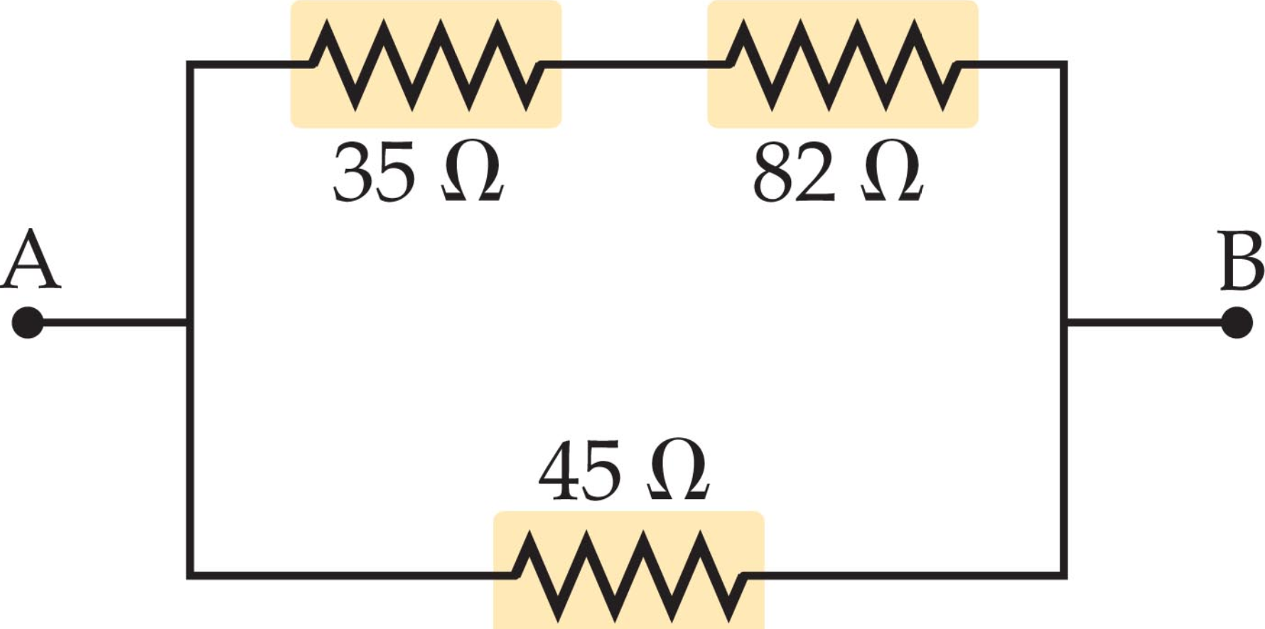
P 771 # 45 Find the power dissipated in a 25 ohm electric heater connected to a 120 V outlet
#46 A current of 2.1 A flows through an 85 ohm resistor. How much power is dissipated?
47 A circuit contains only a 12 V battery and a resistor. If a 1.4 A current flows through the resistor, how much power does the resistor dissipate?
# 48 A 75 W lightbulb operates at a potential difference of 95 V. Find (A) the current in the bulb and (B) The resistance of the bulb

Page 778 # 107 Consider this circuit in which three bulbs, each with resistance R are connected in series. The circuit also contains an open switch. (A) when the switch is closed, does the intensity of light 2 increase, decrease, or remain the same? (B) Do the intensities of lights 1 and 3 increase, decrease, or stay the same when the switch is closed? Explain.
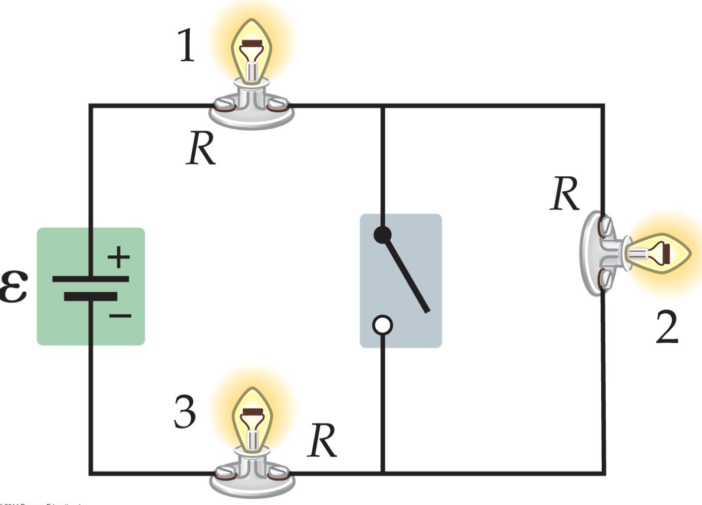
109 Consider the circuit below, in which three lights, each with a resistance R are connected in parallel. The circuit also contains an open switch. (A) When the switch is closed, does the intensity of light 3 increase, decrease, or stay the same? (B) Do the intensities of lights 1 and 2 increase, decrease, or stay the same when the switch is closed?
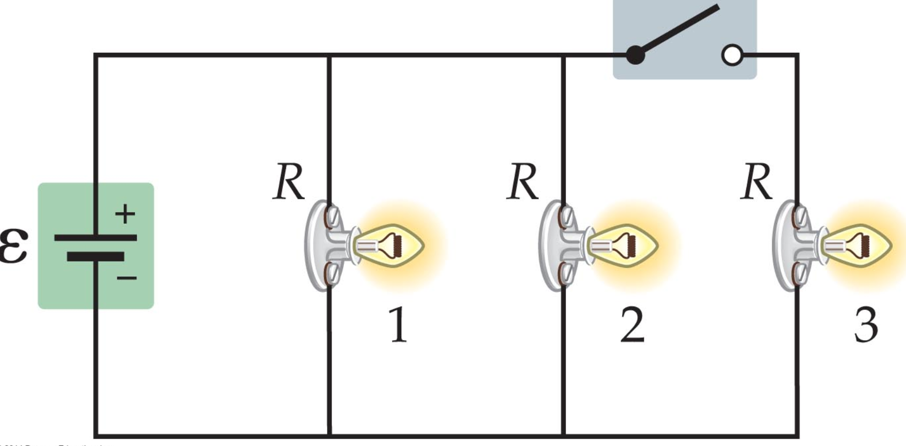
# 122 Two resistors are connected in series to a battery with an emf of 12.0 V. The voltage across the first resistor is 2.7 V and the current through the second resistor is 0.15 A. Find the resistance of each resistor.

