TO MEASURE THE COEFFICIENT OF KINETIC FRICTION BETWEEN A PIECE OF WOOD AND THE LABORATORY TABLE. iPad and SparkVue version.

Theory:
The ratio Ff/Fn (Force of friction/normal force) for any two surfaces is called the coefficient of friction. We will be measuring that force when there is constant speed relative motion between the surfaces.

Procedure:
- Connect the force sensor and open SPARKVue.
- Use the force sensor to determine the weight of the block of wood. Add a 500 gram mass. Calculate the total weight in Newtons.
- Hook up the block to the force sensor
.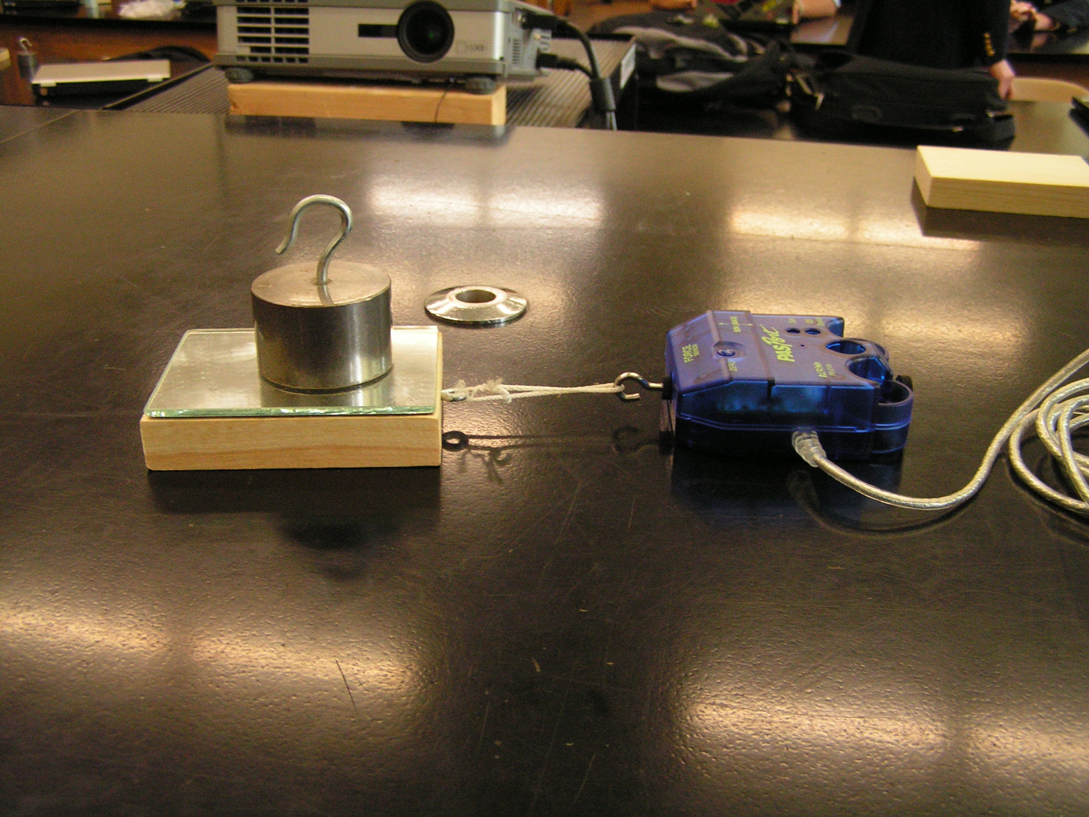

4. Display the force as a graph.

5. Click RUN and then pull the block so that it is moving at a constant, but slow speed.

6. Click STOP. Use the “Smart Tool” to measure the frictional force when the block is moving at a constant speed. Record the data in the table below.

7. Increase the additional mass to 1000 grams, and repeat steps 5,6.

8. Increase the additional mass to 1500 grams and repeat steps 5,6.

9. Increase the additional masses to 2000 grams and repeat steps 5,6,

10. From your data calculate the average coefficient of kinetic friction between wood and the lab table.

The graph in Data Studio will look like this:

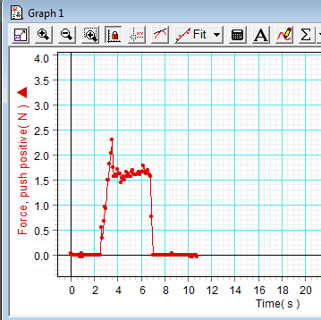

In the graph above, the average of the kinetic friction force is about 1.6 N.

Data:

Weight of wood block alone (Use force sensor): _____________________N

Added Mass | Added weight | Total Weight (=Fn) | Force (=Ff) | Coef. (Ff/Fn)
Grams | Newtons | Newtons | Newtons
500
1000
1500
2000
---------------- | ---------------- | ---------------- | Average>>>>>>

Conclusion: The coefficient of kinetic friction between wood and the lab table was found to be ……………

