To Measure the Wavelength of the Green Line of the Mercury Spectrum

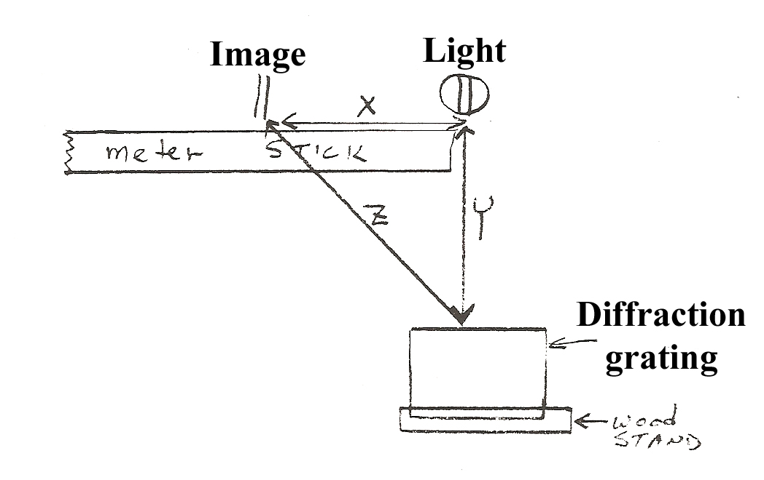

Caution: Do not operate the Mercury Vapor lamp without a filter. The Mercury spectrum contains wavelengths which can cause damage to your eyes.

Procedure: Set up the grating at one side of the table, and the light source at the other. Adjust the position of the grating so that the line of sight from the center of the grating to the light is parallel to the edge of the table.
With your eye close to the grating, look toward the slit. Note the first-order images appear to the right and to the left. Have your partner move some kind of marker (pencil or clip) along the meter stick until it coincides with the image of the slit. Measure and record distances X and Y to the nearest millimeter. Express all measurements in meters.
Obtain measurement d (slit separation) from the instructor. Determine the wavelength of the light from the relationship λ = d sin Θ which becomes λ = d*x/z
Data:
D = ___________ x=_____________ y = _____________
z = _________________(Calculated value)
Conclusion: The wavelength of the green line of the mercury spectrum was found to be
______________________

