Iona Physics -- Lab
To measure the resistance of a small light bulb using Capstone.

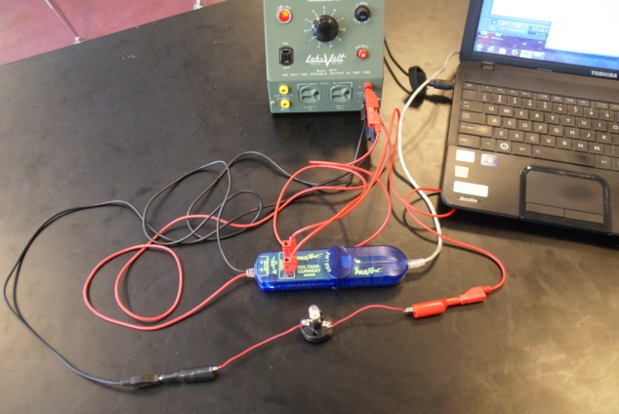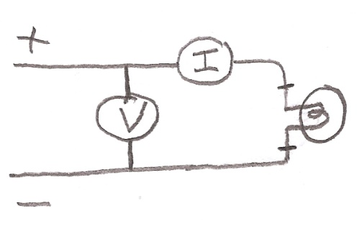

NOTES:
1. It is very important that the voltmeter is connected in parallel and the ammeter is connected in series.
2. NEVER exceed 5 volts during this experiment.
Procedure:
- Attach the voltage-current sensor to the USB-LINK and plug the USB-LINK into your computer.
- Start the PASCO Capstone software.
- Reply to the first screen by clicking on TWO LARGE DIGITS
- On the top display click on SELECT MEASUREMENT then choose VOLTAGE
- On the bottom display click on SELECT MEASURENENT then choose CURRENT
- Near the bottom there is a window which says 20.0 Hz. Click on the down arrow and change that reading to 2 s. That will take a reading every 2 seconds, making it easy for you to record your readings.
- Plug in the variable power supply and turn the knob all the way counter-clockwise. (0 volts)
- Plug the RED VOLTAGE lead of the Voltage/Current sensor into the red (+ DC) jack on the power supply.
- Plug the BLACK VOLTAGE lead of the Voltage/Current sensor into the black (-DC) jack on the power supply.
- Plug a jumper wire into the jack of the red lead which is already plugged into the red(+DC) jack on the power supply. The other end of this wire goes to the + Current jack on the Voltage/Current sensor.
- Plug a jumper wire into the – Current jack on the Voltage/Current sensor.
- Add an alligator clip to the other end of that jumper wire and clip it to one of the wires coming off of the bulb.
- Take another jumper wire. Plug one end of it into the black lead which is already plugged into the black (-DC) jack of the power supply.
- Add an alligator clip to the other end of that wire and clip it to the other wire coming off of the bulb. – At this point your circuit should be complete.
- Hit RECORD on Capstone, and both readings should be zero.
- VERY SLOWLY increase the voltage on the power supply. Every two seconds a reading will be displayed.
- DURING THIS EXPERIMET NEVER EXCEED 5 VOLTS.
- Record the voltage and the corresponding current for at least 10 different voltages between 1 and 5 volts. For each reading calculate the corresponding resistance
- Record your data in a table
Voltage (V) | Current (A) | Resistance (Ohms)

20. Draw a graph with voltage on the X-Axis and Resistance on the Y-Axis.
Conclusion: As the voltage increases, the resistance (increases, decreases, remains constant).

