To measure the Index of Refraction of a liquid using a Laser Distance Meter
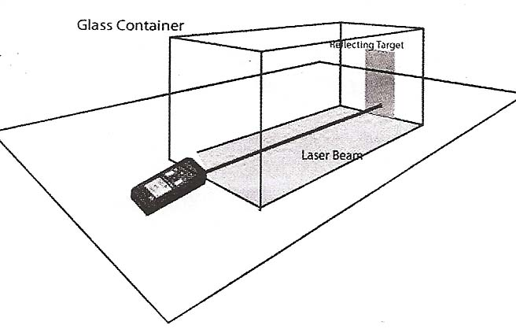

The index of refraction of a substance is defined by the equation
n = c/v
n is the index of refraction,
c is the speed of light in a vacuum,
v is the speed of light in the substance
Measuring the speed of light is as simple (or difficult) as measuring the amount of time it takes to travel a known distance. Measuring time intervals that accurately used to be very costly. No longer!
Our Laser Distance Meter emits 635 nm laser light. It measures the time it takes for the light to be reflected back from the target. Laser distance meters are commonly used in construction as well as in industrial applications. Assuming the light is traveling at the speed c, it then calculates and displays the distance to the target. If the container is filled with a liquid, then the light will travel more slowly. Therefore, the distance meter will be tricked into measuring a longer “apparent length” for the container.
Our Bosch DLR130 can measure distances between 0.05 m – 40 m. Typically it measures distances within an accuracy of +- 1.5 mm.
First, use the laser to measure the length of a rectangular container which is filled with air. That distance will be recorded as d air __________________________________
Then fill the container with a liquid and repeat the measurement.
That distance will be record as d _{liquid} __________________

d = vt can be solved for t t = d/v
leading to t _{liquid} = d _{air} /v = d_{liquid} /c
which can be rearranged c/v = d _{liquid}/d _{air}
Therefore, the index of refraction n = d _{liquid} / d_{air}
Conclusion: The Index of Refraction of the liquid was found to be ___________________________

