Iona Physics Experiment
Time-Dependent Resistor

Resistance is defined as the ratio of voltage to current (R=V/I). It is not necessary for the resistance of an object to be constant. It may depend upon the voltage applied (as it does in a light bulb). It may even depend upon the amount of time the voltage has been applied. In this experiment you will receive a device which has a time-dependent resistance.
Warning: Danger! In this experiment you are working with 120 VAC. 120 volts is dangerous. A stupid mistake can be lethal! DO NOT TOUCH any part of the apparatus while it is connected to the power mains. The resistor should remain in the resistor holder while power is applied. At the first sign of trouble, PULL THE PLUG! DO NOT, under any circumstances, touch the resistor while power is applied.
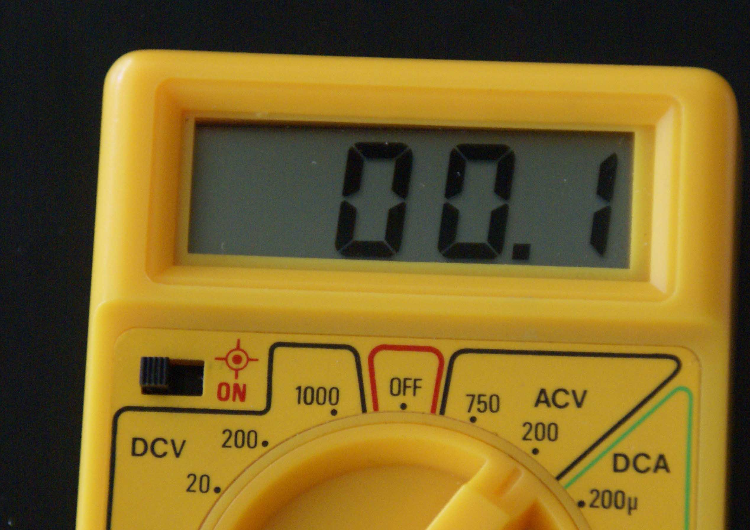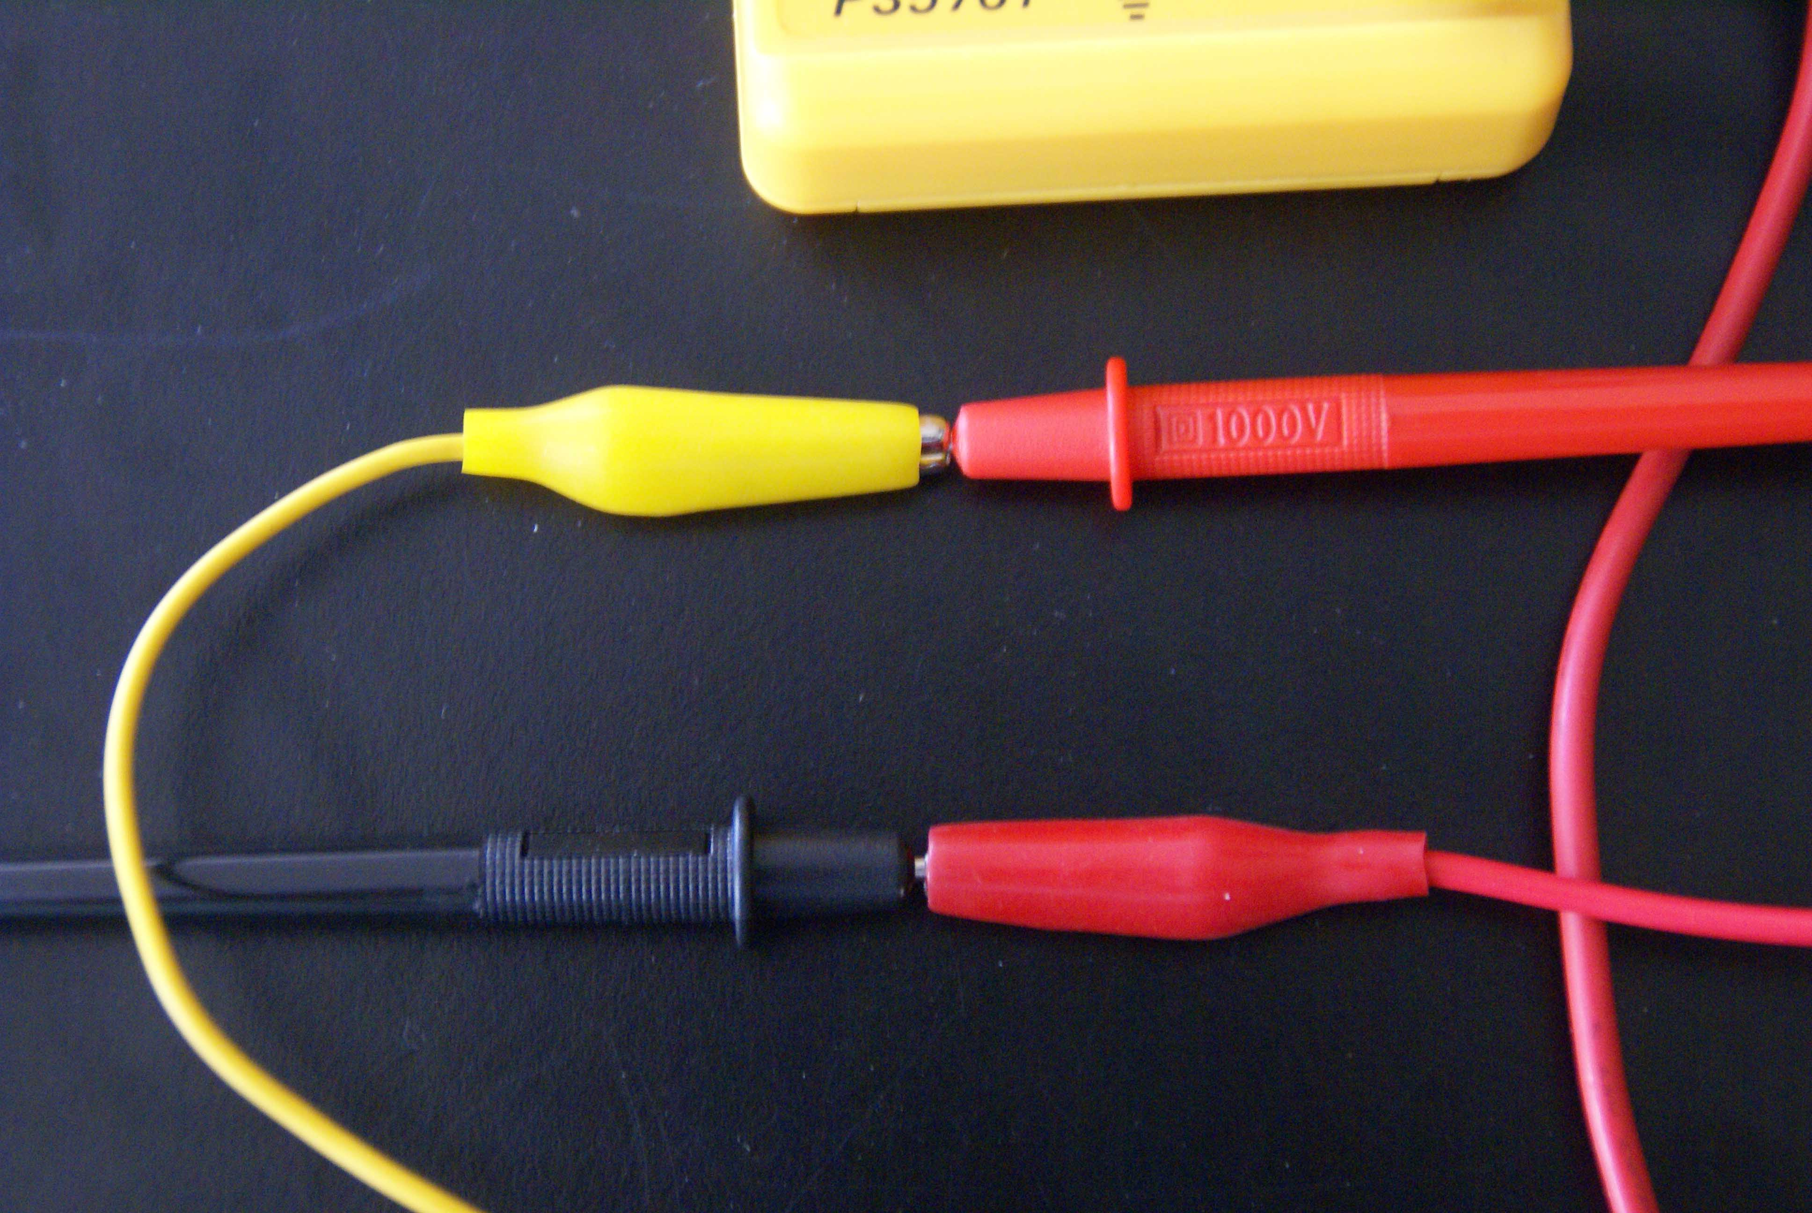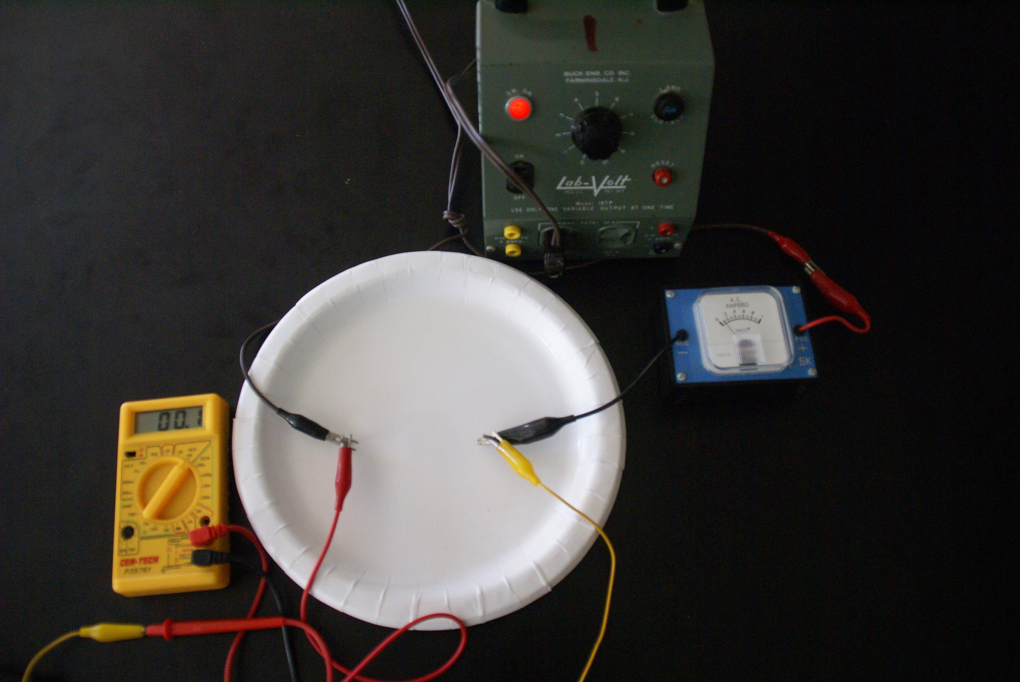
Fig 1 Meter Fig 2 Alligator clips attached Fig 3 Complete setup
(200 ACV scale) to meter probes
Procedure:
- Draw a schematic diagram showing the resistor connected to a power supply. Include an AC voltmeter and an AC ammeter. (AC meters do not have polarity, but they still must be wired properly –voltmeter in parallel and ammeter in series – into the circuit.)
- Wire up your circuit and have it inspected by the instructor before applying power.
- Once you have started current flowing, you should record voltage and current every 20 seconds until the experiment is over. (You will judge that for yourself.) You should record your data in a table like the one below, however your table will have more rows.
- Calculate the resistance of the device and the power used during each time interval.
- Plot a graph with time along the X-axis and resistance along the Y-axis.
- Eat the resistor and the resistor holder.
- Calculate the total amount of electrical work which was done on the resistor.

Names ___________________________________________Date___________
Time Dependent Resistor Lab
Data:
Time  (seconds) | Voltage  (Volts) | Current  (Amps) | Resistance (ohms) | Power  (Watts)
20
40
60
80
…
(Add more rows to the table as needed)

Conclusion: _______________________Joules of electrical energy were used.

