Iona Prep Physics Laboratory Exercise

Period of a Simple Pendulum

Question: I am building a clock. How long should a pendulum be to have a period of 1 second?

To answer this question, you must find out how the rate at which a pendulum swings back and forth depends upon the length of the pendulum. You will then be able to predict how long a pendulum should be in order to have its bob to swing back and forth once every second.
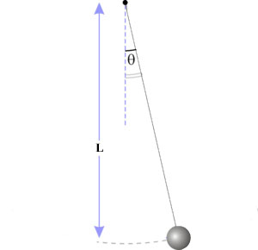
- The Length of the pendulum (L) is measured from the support to the center of the bob.
- Keep angle theta as small as practical in order to get the best measurements.

Apparatus: Pendulum clamp; pendulum bob; gallows pole, meterstick; stopwatch

A simple pendulum consists of a mass (called the bob) suspended by a thin string from a fixed support. A complete vibration of a pendulum consists of two swings of its bob, one forward and the other back, so that the bob returns to its original position. The time for a complete vibration is called the period of the pendulum and is designated by the letter T.

In order to find the length that gives a pendulum a period of 1 second might require a great many trials before the correct length is found. A better method is to determine the period of a series of pendulums of increasing lengths. If the data is plotted on a graph, the length of a pendulum of period 1 second can be determined from the graph.

Procedure:
- Use Capstone to measure the period of a pendulum of a certain length.
- Repeat step 1 using a variety of lengths from about 50 cm down to about 10 cm.
- On graph paper plot your data with length (L) along the x-axis and period (T) along the y-axis.
- If it appears to be a straight line, draw a straight line. If, on the other hand, it appears to be a curve, then draw a smooth curve.
- Using your graph, make your best estimate of how long a pendulum should be in order to have a period of exactly one second.

Data:

Length of Pendulum (cm) | Period (T) (sec)

Conclusion:

A pendulum _________cm long will have a period of 1 second.

