Lab: To measure the efficiency of a roller coaster in converting potential energy into kinetic energy.

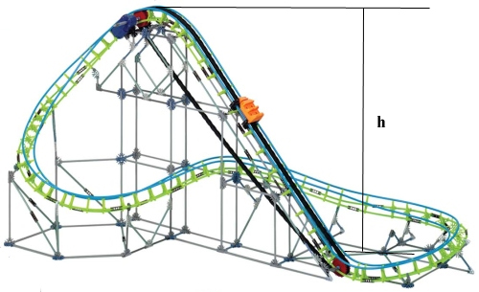

Discussion:
The conversion of energy from one form to another (for example from potential to kinetic) is virtually never 100% efficient. That is, some of the energy escapes in other forms. For example the potential energy of a roller coaster at the top of a hill is converted to kinetic energy at the bottom, but some energy is lost to friction, the production of sound, slight movement of the rails, and other forms which are of no use.

In this experiment we will measure how high the top of the track is above the bottom of the track and predict how much kinetic energy the cart should have at the bottom. We will then measure the kinetic energy at the bottom and calculate the efficiency of the conversion.

Potential Energy at the top = mgh
Kinetic Energy at the bottom = (1/2)(m)(v)²

Efficiency = 100%(Kinetic Energy at bottom)/(Potential Energy at top)

Efficiency = 100% * mv²/2mgh

Eliminating the m gives Efficiency = 100%*V²/2gh

Data: h = __________________ V= _______________________ g = 10 m/s²

Conclusion: The Roller Coaster was found to be ___________ % efficient in changing potential energy into kinetic energy.

