Iona Prep Physics – Lab Exercise

To locate the focus and measure the focal length several optical components.
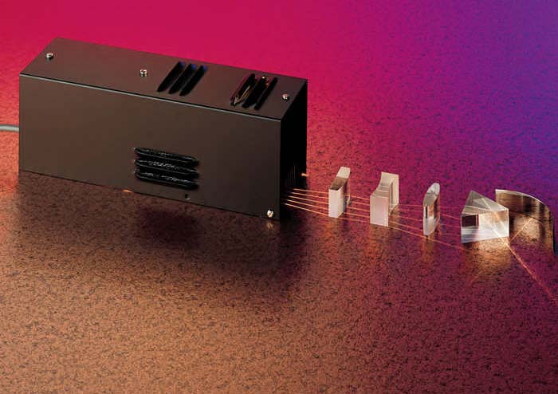

- Place the ray box near the edge of a piece of paper in such a way that the rays cross most of the width of the page. Note the rays are diverging.
- Place the plano-convex lens in front of the ray box with the flat side facing the ray box.
- Adjust the position of the lens so that the rays are parallel to each other.
- Trace the ray box, the plano-convex lens and the light rays on the worksheet.
- Place an optical component in the path of the light rays and adjust it to locate the focus.
- On the worksheet trace the optical component and the new path of the light rays.
- Mark the location of the component’s focus on the worksheet.
- Measure and record the focal length of the optical component.

Repeat the above procedure for each of the optical components.

Conclusion:
(For each component)
The focal length is measured from… to …
The focal length of the ___________ was measured to be _________.

