Iona Physics Lab Exercise
Lab: To measure the wavelength of the green line of the Mercury spectrum
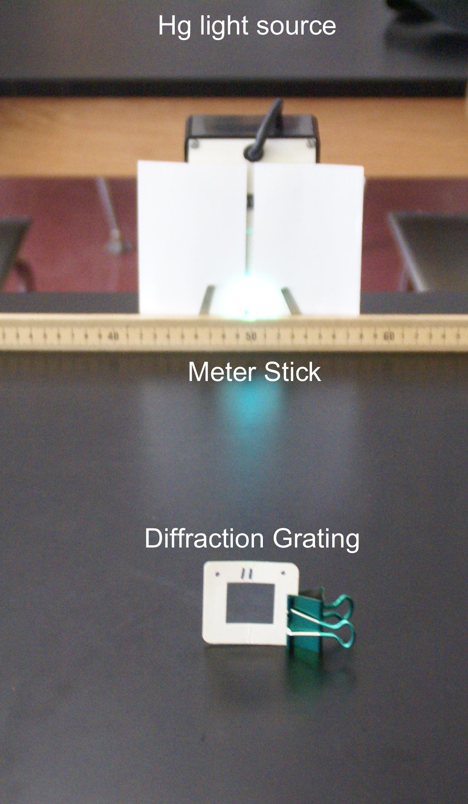
Introduction: The Hg light passes through a diffraction grating and you see an interference pattern superimposed on the meter stick.
Data:
Location of the LEFT maximum = ____________ cm (A)
Location of the central maximum = _________ cm (B)
Location of the RIGHT maximum = __________ cm (C)
Distance of the LEFT maximum from the central maximum = |B-A| = _______ cm (E)
Distance of the RIGHT maximum from the central maximum = |C-B| = _______cm (F)
Average distance of maximum from central = (E+F)/2 = __________cm (X)
Distance from the diffraction grating to the meter stick = ____________ cm (L)
We will assume the spacing of the diffraction grating slits is d = 1.80 x10⁻⁶ meters.
Use the relationship for the wavelength λ = d*X/L
Calculate the wavelength of the green line of the Mercury Spectrum.
Conclusion:
The wavelength of the green line of the Hg spectrum was found to be __________________

