Iona Prep Physics

Index of Refraction of Water:
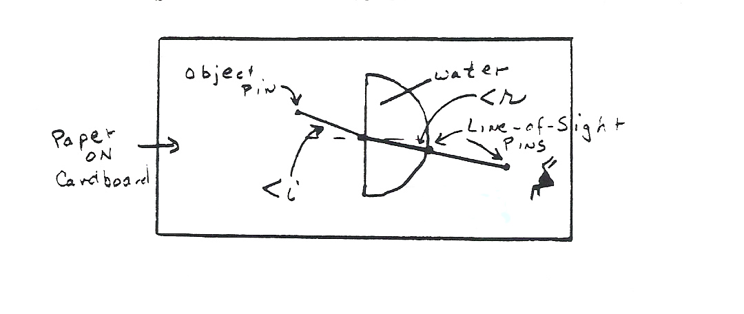Theory:
The index of refraction of a substance is defined as sin<I / sin<R for a light ray entering the substance from air.

In this experiment you will have a semi-circular dish of water. You will trace the light ray as it enters the flat side and travels through the water. Take care that the light enters the water at the center of the flat side. That way it will travel along a radius and will not bend as it exits at the curved side.

Using pins and sighting through the water. Place a pin at the center of the straight side and another at an angle of incidence greater than 25 degrees. Sight through the water and use a pin to locate the refracted ray. Repeat this until you have 5 trials at different angles of incidence.

Calculate the Sin of each of the angles and then calculate the index of refraction for each trial. Finally, calculate the average of the last column. That is your conclusion.

<i | <r | Sin i | Sin r | N=sin i/ sin r
XXXXXXX | XXXXXXX | XXXXXXX | Average >>>>

Conclusion:
The index of refraction of water was found to be ____________________________

