Iona Prep Physics

Experiment: To measure the Index of Refraction of a piece of glass by tracing light rays.

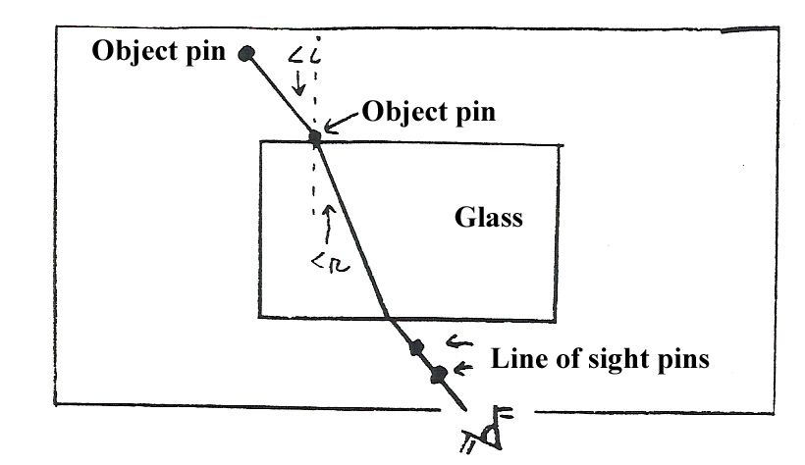

Procedure:
Set up the apparatus as shown. Draw the outline of the glass on the worksheet. Mark a point on the air/glass boundary by placing a pin vertically right next to the glass as shown. Place the other object pin so that it makes an angle of incidence of 20 degrees or more. View the object pin through the other side of the glass and line up two pins to mark the line of sight. Mark the pinholes so that you can draw rays. Note that the bending occurs ONLY at the air/glass boundary. The line of sight does NOT bend at a pin, but at the air/glass boundary. Measure the angle of incidence and the angle of refraction and calculate the index of refraction by using the relationship
n = sin <i/sin<r

Repeat at least 4 times for different angles of incidence and calculate the average.
Data Table:
<incidence | <refraction | Sin <i | Sin <r | Sin <i/ Sin <r
xxxxxxxxxxxxx | xxxxxxxxxxx | xxxxxxxxxxxx | Average >>>>

Conclusion:
The index of refraction for the plate of glass was found to be ……
The speed of light in the plate of glass is calculated to be …….

Include the worksheet as part of the lab report.

