Iona Prep Physics

Problem: To compare the elasticity of a steel spring with that of a rubber band.

Theory: When some substances are stretched and then released, they regain their original shape and length. The ability of a body (like a spring) to regain its original form after the force stretching or deforming it is removed is called ELASTICITY. When the deforming force is greater than a certain point, called the ELASTIC LIMIT, the body no longer regains its original shape after the force is removed. Instead, it remains permanently deformed. In this experiment, you will compare the elasticity of a steel spring with that of a rubber band.
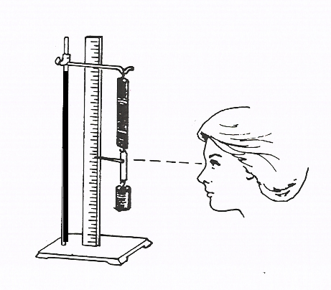

Procedure:
- Set up the apparatus as demonstrated by your instructor. If possible, begin with the pointer set to zero when the hanger is unloaded.
- Add some mass to the hanger and note the new location of the pointer. Record the mass on the hanger and the elongation (current reading of the pointer minus the unloaded reading of the pointer).
- Repeat for several different masses, each time recording the total mass and the elongation from the starting position. Tabulate your data.
- Repeat the entire experiment using a rubber band in place of the spring, again tabulating your data.
- Create a graph. Plot the elongation (Y-axis) against the force (X-axis) for the spring and also for the rubber band. (You may use two different pieces of graph paper, or one piece of graph paper with the two lines drawn in different colors. If you use different colors, be sure to indicate which is which).

Conclusion: Hooke’s Law states that the elongation is directly proportional to the force.
F=kx
F is the force
x is the elongation
k is a constant, called Young’s modulus.

Examine your experimental points. Remember experimental points are always a bit “fuzzy”, there is some limited accuracy in both the x and y directions.

If the graph appears to be a straight line, the relationship between F and x is a direct proportion. If the graph appears to be a straight line, draw a straight line which comes closest to the most points. Calculate the slope of the graph.
Slope = (change in y)/(change in x)

Conclusion: The (spring/rubber band) obeyed Hooke’s law. Young’s modulus was measured to be …………..

If the graph does not appear to be a straight line, the relationship is not a direct proportion and the item does not obey Hooke’s law. You should draw a smooth curve which passes as close as possible to your experimental points.
Conclusion: The (spring/rubber band) did not obey Hooke’s law.

Considerations for drawing graphs:
- The graph should have a title
- The scales (x and y) DO NOT have to be the same. Generally, scales will have different units (labels) and therefore cannot be the same! Scales should normally be linear, with each box representing the same amount of increase.
- Each axis must be labeled with variable (force, elongation) and the units (cm, g, N), and the scale
- If drawn by hand, each data point should be surrounded by a small circle.
- Your graph should be either a straight line or a smooth curve. It should never be a jagged line connecting the points.
Steel Spring
Force (grams) | Elongation (centimeters)

Create a similar data table for the rubber band

