Iona Prep Physics Lab Exercise: Series Circuit (Doorbell)
A Series Circuit has only one path for current.
In this lab you will
1. Draw the schematic diagram for a doorbell circuit with one button
2. Build the circuit
3. Test the circuit. The bell should ring when and only when the button is pushed.
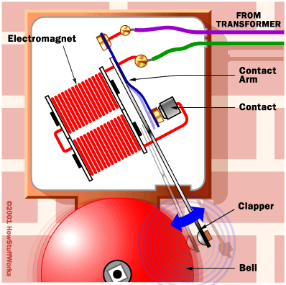

Schematic Diagram Symbols:

Battery or power supply | 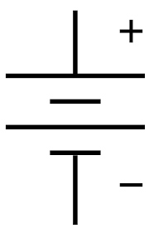
Pushbutton | 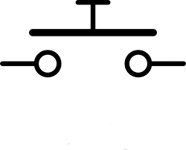
Bell (There are several variations, this may be the most obvious.) | 