Lab: To compare the total cost of ownership of the same amount of illumination provided by an incandescent bulb, a compact fluorescent bulb, and an LED bulb.
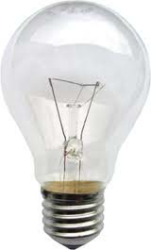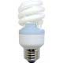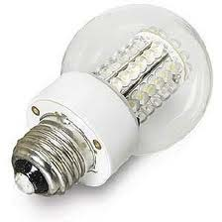
Incandescent bulb Compact Fluorescent LED
The claim (found on the Internet)
An LED light bulb can last you up to 30,000 hours. That averages out to 6 hours of light per day for 12 years.
LED light bulbs are so energy efficient that, depending on how often you have them on, they'll actually pay for themselves in just over a year.
The best way to conserve energy is to use less of it. LED light bulbs are directional - which means that they only put the light where you aim it or where you need it. Incandescent bulbs, on the other hand, just sit there and throw their glow all over the place - wasting electricity and generating heat.
LED light bulbs run cool, so they're safer to use than fragile, burning hot halogen and incandescent bulbs.
LEDs turn on instantly - which has been a big benefit in car brake lights and is also a welcome feature when testing lights in a dark basement.

Note: To make a valid comparison you need to have the same amount of lamination at a fixed distance.
Procedure:
Record the price of each bulb.
Determine the expected life of each bulb.
Record the cost of electrical energy in your area ( $x.xx / kilowatt hour)
Set up each bulb at exactly the same distance from a light sensor. Adjust the voltage so that each bulb is producing the same amount of illumination as measured by the sensor. Record the voltage and current. Calculate the power used by each bulb.
Calculate the total cost of ownership for each bulb after it has operated for some convenient number of hours. You need to consider the cost of the bulb(s), and the cost of the electricity.

