Iona Prep Physics Experiment
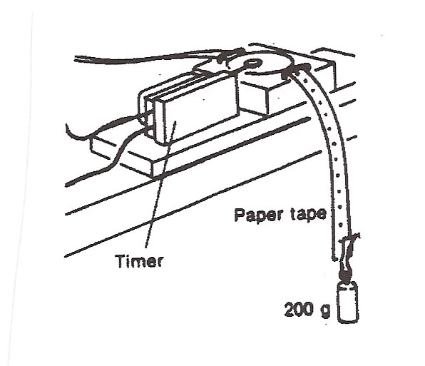
To Examine The Relationship Between Distance And Time For An Accelerated Object.
In this experiment you use a simple dot timer to attempt to measure the acceleration of a small mass which is being pulled down by gravity.
Friction in the system is not negligible, so the acceleration you measure will undoubtedly be less than the acceleration of gravity without friction.

Procedure:
1. Set up the dot timer and some paper tape at the edge of the table.
2. Attach a mass of about 200 grams to the tape.
3. Set the timer going and release the mass, permitting it to fall to the floor.
Analysis:
1. Beginning with the first dot, assign a number to every THIRD dot. The first dot is #0, the third is #1, the sixth is #2, and so on.
2. Measure the distance from dot #0 to each other numbered dot. Call these distances X₁ ,X₂ , X₃ and so on. Measure those distances to the nearest millimeter.
3. Tabulate your results and enter them into an Excel spreadsheet.
4. Highlight the Time and Distance from start columns and Insert a scatter plot (without connecting the dots)
5. Then use trendline to insert a polynomial plot and also display the equation and R² .
6. Use the equation to determine the actual effective acceleration of the mass.
Conclusion: The acceleration of the mass was found to be …..

Dot # | Time (seconds) | Distance from Start (cm) [X_{n} ]
0 | 0
1 | 0.05
2 | 0.10
3 | 0.15
4 | 0.20

