Iona Preparatory Science Department - Physics Lab

To measure the acceleration of gravity using a mixture of 16th and 21st century technologies (inclined plane and iPad).

You will use an accelerometer to measure the acceleration of gravity. It would seem easy to do this by simply dropping the accelerometer. However it would not be easy to assure the accelerometer did not rotate, thus spoiling the measurement. It also would be difficult to avoid damaging the accelerometer.

We will use an inclined plane to “dilute” gravity. We will fix the accelerometer to a low-friction cart.

Diagram:
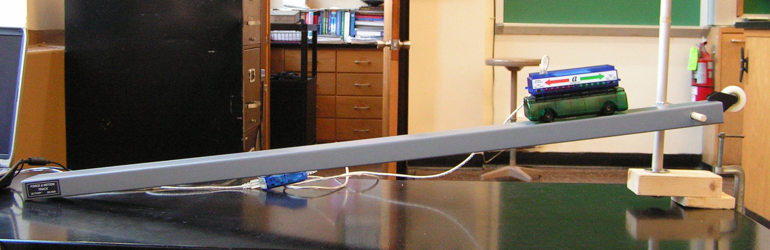

Angle of inclination:
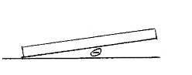

Support Detail: 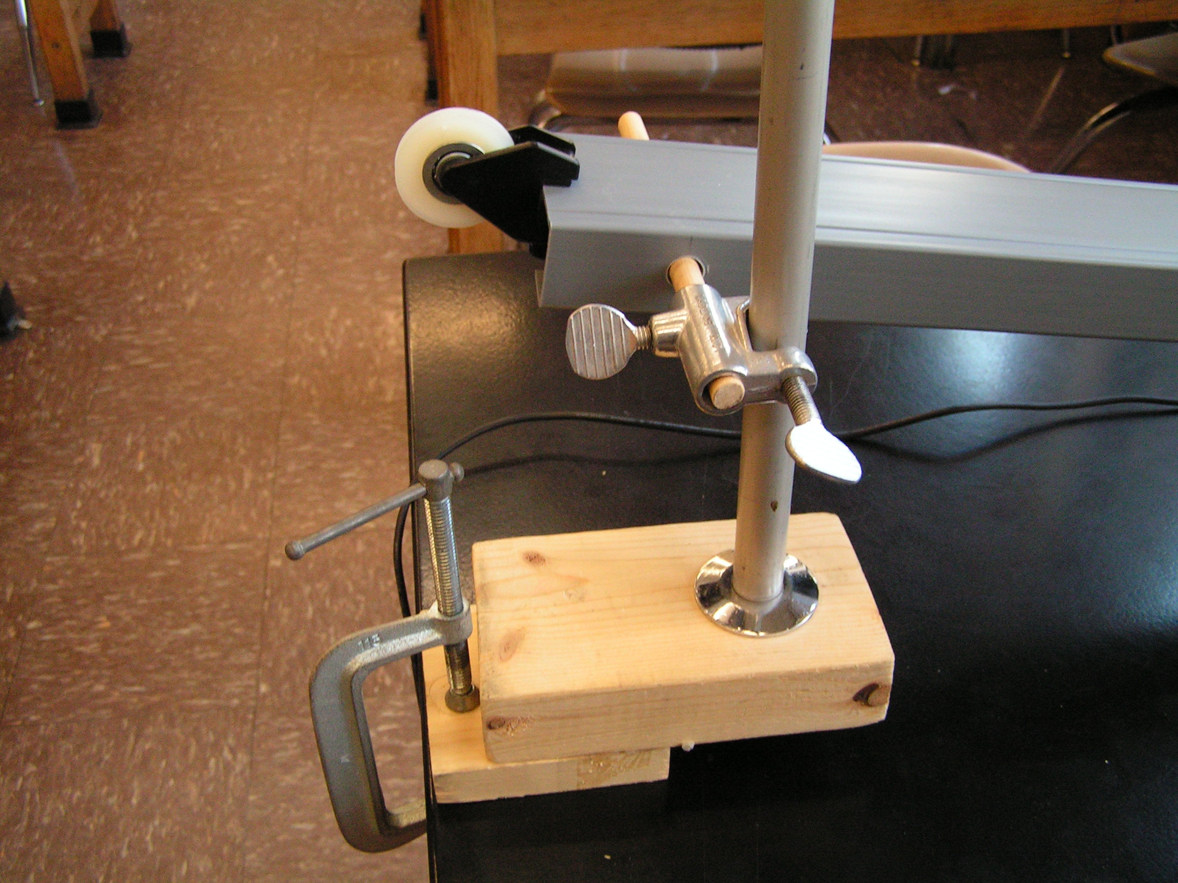
Procedure:
- Set up the inclined plane at a very low angle.
- Attach the accelerometer to the low friction cart.
- Attach the accelerometer to the Air link.
- Open SPARKvue and verify that the Bluetooth link is operating.

For each data run:
- Use the iPad Clinometer App to measure the angle of inclination of the plane. Record the angle.
- Place the cart on the plane and zero the accelerometer.
- Press START (green arrow) on SPARKvue
- Let the cart accelerate down the plane
- Press STOP on SPARKvue, expand the scale of the graph and record the acceleration.

Repeat for several different (increasing ) values of Θ the angle of inclination
Data Analysis

Θ Angle of Inclination degrees | A Acceleration  (m/s^2) | g = (A / sin Θ)  (m/s^2)
 | AVERAGE VALUE >>>>
Calculate the average value for the acceleration of gravity

Conclusion:
The acceleration of gravity was found to be ……………………………..

