Iona Preparatory Science Department - Physics Lab

To measure the acceleration of gravity using an inclined plane

You will use an accelerometer to measure the acceleration of gravity. It would seem easy to do this by simply dropping the accelerometer. However it would not be easy to assure the accelerometer did not rotate, thus spoiling the measurement. It also would be difficult to avoid damaging the accelerometer.

We will use an inclined plane to “dilute” gravity. We will fix the accelerometer to a low-friction cart.

Diagram:
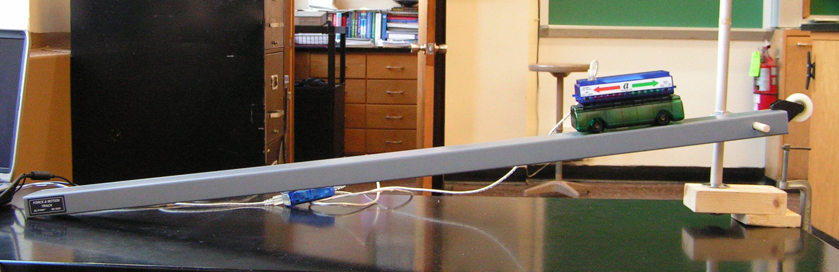

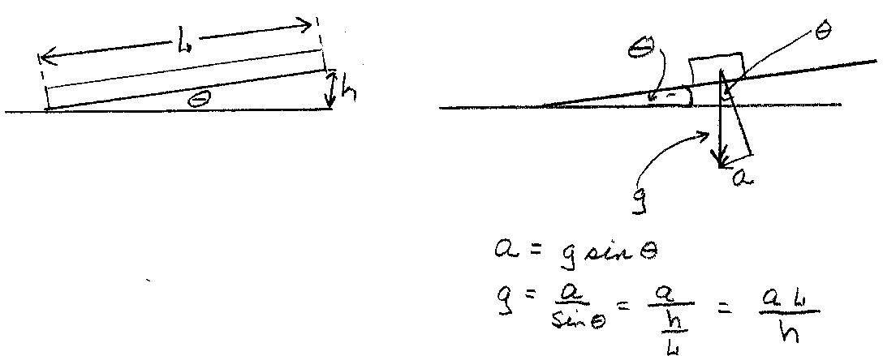
Support Detail: 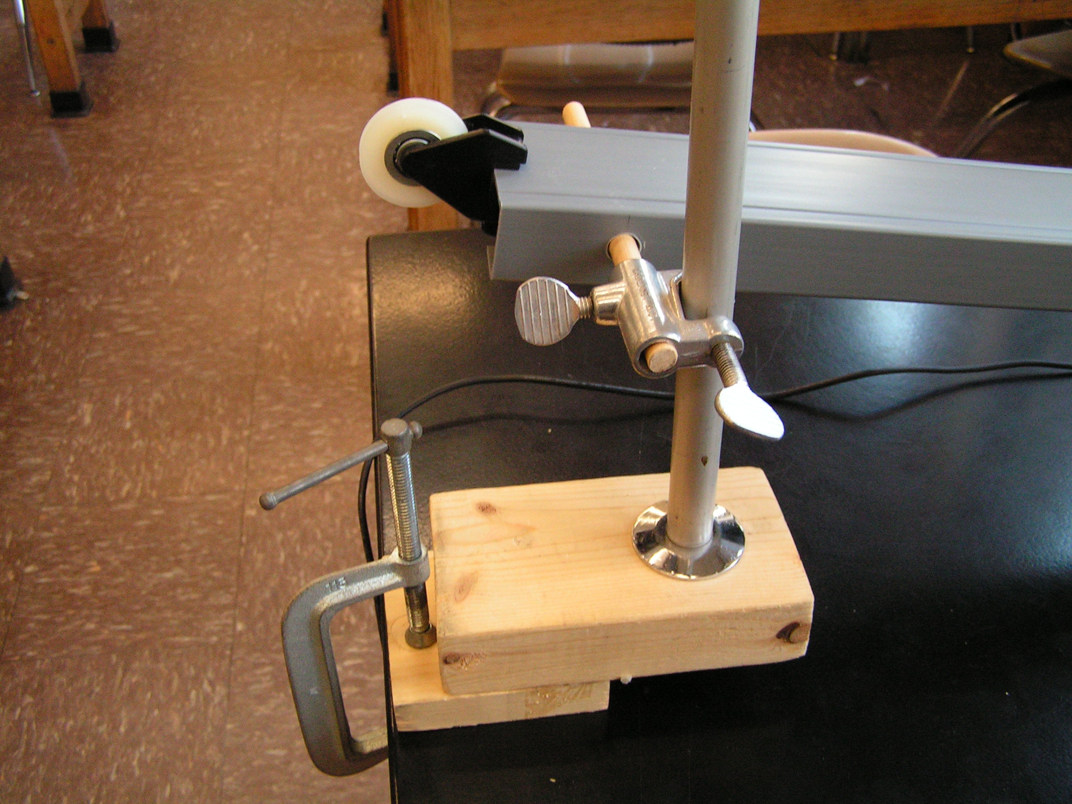
Procedure:
- Set up the inclined plane at a very low angle.
- Attach the accelerometer to the low friction cart.
- Attach the accelerometer to the USB link.
- Attach the USB link to the computer.
- Run DATA STUDIO
- Measure L, the length of the inclined plane.

For each data run:
- Measure h, the height of the end of the plane above the table.
- Place the cart on the plane and zero the accelerometer
- Press START on Data Studio
- Let the cart accelerate down the plane
- Press STOP on Data Studio
- Expand the scale of the graph and record the acceleration of the car
- Use “Experiment-Delete All Data Runs” if necessary

Repeat for several different values of h
Data analysis:

L = ____________________

h (cm) | a (m/s^2) | g = a*L/h (m/s^2)
Calculate the average value for the acceleration of gravity

Conclusion:
The acceleration of gravity was found to be ……………………………..

