Iona Prep Physics

Problem: To calculate the spring constant of a steel spring.

Theory: When some substances are stretched and then released, they regain their original shape and length. The ability of a body (like a spring) to regain its original form after the force stretching or deforming it is removed is called ELASTICITY. When the deforming force is greater than a certain amount, called the ELASTIC LIMIT, the body no longer regains its original shape after the force is removed. Instead, it remains permanently deformed. In this experiment, you will add weights to a spring, measure how far it stretches, and calculate its spring constant.
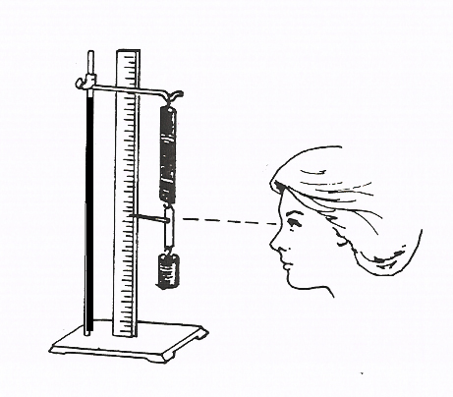 The scale is in centimeters.

Procedure:
- Set up the apparatus as demonstrated by your instructor. If possible, begin with the pointer set to zero when the hanger is unloaded.
- Add some mass to the hanger and note the new location of the pointer. Record the mass on the hanger and the elongation (current reading of the pointer minus the unloaded reading of the pointer).
- Repeat for several different masses, each time recording the total mass and the elongation from the starting position. Record your data in a table.

Steel Spring
Force (grams) | Elongation (centimeters)

- Create a graph with force along the x-axis and elongation along the y-axis.

Considerations for drawing graphs:
- The graph should have a title
- The scales (x and y) DO NOT have to be the same. Generally, scales will have different units (labels) and therefore cannot be the same! Scales should normally be linear, with each box representing the same amount of increase.
- Each axis must be labeled with variable (force, elongation) and the units (cm, g, N), and the scale
- If drawn by hand, each data point should be surrounded by a small circle.
- Your graph should be either a straight line or a smooth curve. It should never be a jagged line connecting data points.

Hooke’s Law states that the elongation is directly proportional to the force.
F=kx
F is the force
x is the elongation
k is a constant.
Calculate the value of the constant (k) and be sure to include the proper label.

Conclusion: The spring constant was found to be ………………..

