Iona Preparatory School Science Department

Experiment: To Measure the Speed of Sound using Resonance

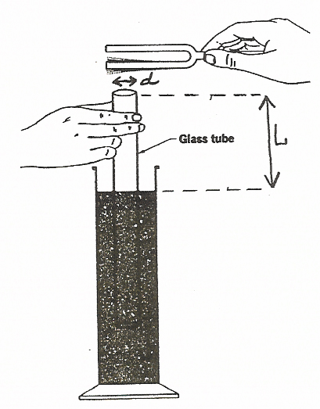

Introduction:
Resonance occurs when the natural frequency of vibration of two objects are the same. An air column in a closed glass tube produces its best resonance when it is approximately one-fourth as long as the wavelength of the sound which it reinforces. For example, a tube one meter long produces resonance with a sound wave which is about four meters long. There is a small correction for the internal diameter of the tube. The wavelength of the sound may be calculated from the resonant length of a tube by the formula
λ = 4(L +0.4d)
where L is the length of the closed air column and d is the diameter of the tube.
You may then use the relation v=fλ to find the speed of sound.

In this experiment you will hold a tuning fork above an air column and then adjust the length of the column until you have the best resonance. You should record both L and d as well as the frequency of the fork. Repeat for at least 3 different frequencies.

Calculate the speed of sound and then use the average of the speeds found as your conclusion.

Note: Strike the tuning fork with a special rubber hammer or on the heel of your hand. DO NOT strike the tuning fork on the table or any other hard surface as you may cause a dent or chip.

Trial | Length L  (m) | Diameter d  (m) | Wavelength λ (m) | Frequency  f Hz | Speed
1
2
3
Average | xxxxxxx | xxxxxx | xxxxxxx | xxxxxxx
(The average in the last column is your experimental value for the speed of sound.)
Conclusion:
The average speed of sound was found to be ___________________________

OPTIONAL EXTENSION
In this experiment you can actually calculate the “accepted” value for the speed of sound in order to see how close your experimental value is to the accepted value..

If you want to calculate the “accepted value” for the speed of sound you measure the temperature and use the following relation:
v = 331 m/s + (.59m/sCº )(temp)

Data:
Temperature __________________ Speed of sound (accepted) ___________________

Conclusion:
The average speed of sound was found to be ___________________________
The accepted value for the speed of sound was found to be ________________
The percent error was ___________________

Reminder:
% error = [100%]*((Experimental value) – (Accepted value))/(Accepted value)

