Iona Prep Physics Lab Experiment

To Investigate Reflection from a Plane Mirror
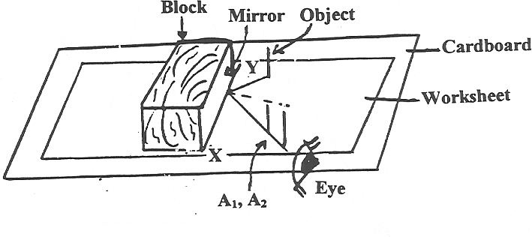
Diagram 1

Procedure:
Using a ruler, draw a straight line across the center of a large piece of white paper. Label the line XY. Place the paper on a piece of cardboard. Attach the mirror to the support block with rubber bands and place it on the white paper so that the back reflecting surface of the mirror is exactly on the line XY. It is important that the back reflecting surface of the mirror remains on line XY throughout the experiment. Check this often!

Place a straight pin which will be called the OBJECT PIN about 7 cm in front of the mirror as illustrated by your instructor. Mark this as OBJECT on the piece of paper.

Look at the REFLECTION of the OBJECT PIN (not the pin itself) and mark your line-of-sight with two pins placed about 5 cm apart as shown on Diagram 1. Label the positions of sighting pins as A1 and A2.

Remove pins A1 and A2, leaving the OBJECT PIN in place.
Now look at the REFLECTION of the OBJECT PIN again from a different location and mark your line-of-sight with two pins as before. Label the positions of the sighting pins as B1 and B2. Repeat for two other locations C1 C2 and D1 D2.

Remove the mirror and OBJECT PIN.

Now draw a line through points A1 and A2 up to line XY. Draw a line from the OBJECT PIN to the place where line A1-A2 hits the mirror. Line O-Mirror is the incident ray and Mirror-A1 A2 is the reflected ray. Draw the normal and measure the angles of incidence and reflection and record them in a table.
Repeat the above paragraph for B1 B2 – Mirror and Mirror – Object, then C1 C2 Mirror – Mirror- Object and also for D1 D2-Mirror and Mirror-Object.

Draw lines A1-A2, B1-B2, C1-C2, D1-D2 back BEHIND the mirror. Where they intersect is the location of the image. Your final worksheet should look like Diagram 2.

Diagram 2

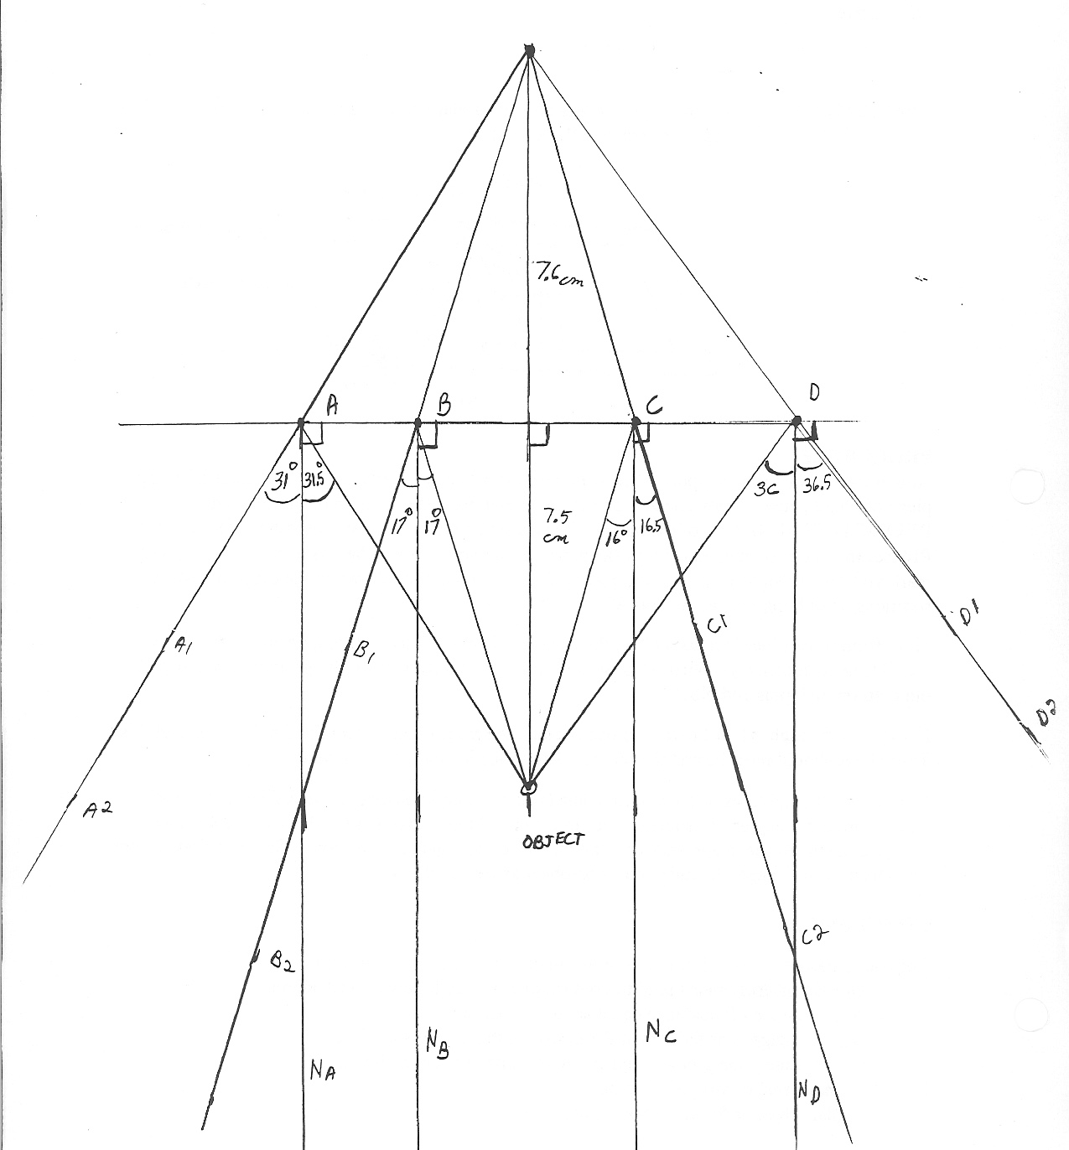

In your conclusion answer the following questions:
1. Do your measurements confirm or deny the following statements:
a) The angle of incidence equals the angle of reflection.
b) The Image is as far behind the mirror as the object is in front of it.
c) The line joining the object and the image is perpendicular to the mirror?

2. Images can be divided into two types. A real image is inverted and can be projected on a screen. A virtual image is erect and cannot be projected on a screen. Both can be seen with the eye. Is the image produced in this experiment real or virtual?

