Security Gate Project: (Revised 10/23/22)
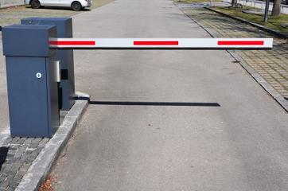

Think about the security gate at the entrance to Iona Prep. During the normal school day, the gate is open. However, at night the gate is closed. If you want to get in, you must enter a secret code.
The project is to model this system. You will wire a servo to control the gate, and program your computer to open the gate when the secret code is entered. You will determine the secret code. When the gate opens, it stays open for 30 seconds and then closes. You will demonstrate that it works to the teacher and hand in a report as detailed by your teacher.

Extensions:
1. Add a green LED and a red LED. If a correct code is entered the green LED goes on and the gate opens. If an incorrect code is entered the red LED goes on for 30 seconds and the keyboard is ignored for that amount of time. Another attempt may be made after the red LED goes off.
2. Add a detector (a button will do) which you can pretend is under the road. It detects when the car has passed and the gate closes after the car has passed.
3. (A real challenge): Add a piezo speaker. If THREE CONSECUTIVE wrong codes are entered then not only does the red light come on but the speaker begins making an annoying sound which continues until the correct code is entered. The annoying sound can be a simple frequency beeping intermittently, or – you can generate some other really annoying sound.

