Passing BLOCKLY code from one person to another:
When you have a working block of code which you want to share you
- Download it to your computer
- Give it a useful name and save it in a known location
Then to use it elsewhere:
- Create a new project
- Upload it to the new project.
A specific example:
I have written a function which I want to share with someone, or use in another place.
- In the upper right of the BLOCKS page you will see this toolbar 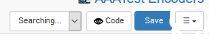
- Click on the three horizontal lines and this menu will open
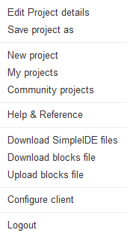
- Click on “Download blocks file”
- Note the name, or give it a new name and click “Confirm”
- Choose Save File and click OK.
- The file is now in your downloads folder.
- You may move the file to any folder you wish.
I want to get the file to use it as is, or to include it in a larger program:
- Open a new project and go to the blocks page
- Click on the 3 horizontal lines
- Click upload blocks file
- Click Browse and then navigate to the file. It will have a .svg extension.
- Click on the file
- Click APPEND

