Security Gate Project:
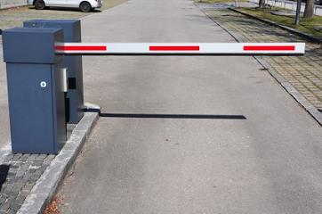

Think about the security gate at the entrance to Iona Prep. During the normal school day the gate is open. However, at night the gate is closed. If you want to get in, you must enter a secret code.
The project is to model this system. You will wire a servo to control the gate, and program your computer to open the gate when the secret code is entered. The secret code will be your birthday (without the year) in the form mmdd. For example, if your birthday is February 17 the secret code would be 0217. If your birthday is November 3 the code would be 1103. When the gate opens, it stays open for 30 seconds and then closes.
Extensions:
1. Add a green LED and a red LED. If a correct code is entered the green LED goes on and the gate opens. If an incorrect code is entered the red LED goes on for 30 seconds and the keyboard is ignored for that amount of time. Another attempt may be made after the red LED goes off.
2. Add a detector (a button will do) which you can pretend is under the road. It detects when the car has passed and the gate closes after the car has passed.

