Iona Preparatory School Science Department
Lab: To Determine How the Period of a Pendulum Depends upon its Length

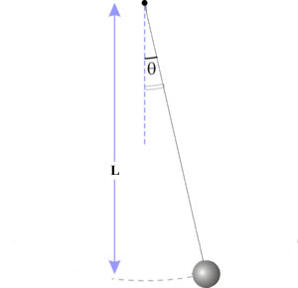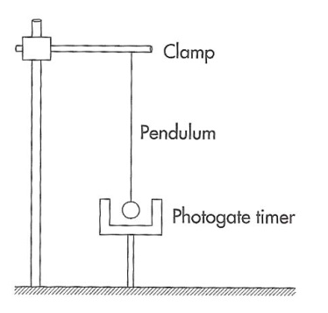
The Length of the pendulum is measured from the support point to the center of the bob.
Abstract:
In this experiment you measure the period of a pendulum at various different lengths. After that you look for a mathematical relationship between the length and the period.
You will use the Capstone program with a Photogate to measure the period of the pendulum. This saves time while simultaneously reducing the experimental error involved in using a stopwatch.
Experimental Setup:
1. Connect a Photogate to the Digital Adapter.
2. Connect the Digital Adapter to the USB Port.
3. Connect the USB Port to the computer.
4. Launch Capstone.
5. Drag a table from the Right of the Capstone screen into the work area. Place it as far to the right of the work area as you can.
Now you have to get the software to recognize the Photogate and use it to control a timer.
6. Click Hardware setup (Left of screen).
7. Click (Add sensor/Instrument) near bottom of pop-up window.
8. At the top of the popup window, CHANGE "Passport Sensors" to "Science Workshop Digital Sensors"
9. Choose Photogate.
10. On the left click Timer setup.
11. Leave Pre-Configured Timer and click NEXT.
12. Leave Photogate and Click Next.
13. When it says select a timer, open the window select Pendulum Timer.
11. Leave PERIOD selected. Click next.
12. Pendulum width does not matter. Click next.
13. Click Finish.
14. At the top of the chart, click (Select Measurement) and select Period (s).
Now you are ready to perform the experiment
15. Set the pendulum moving so that it interrupts the Photogate beam at the bottom of each swing.
16. Click Record
17. Let data accumulate for 10 periods. Record the Length of the pendulum and the average Period in the table below.
18 Click “Delete Last run” to clear the table and prepare for the next run.
19. Change the length of the pendulum and return to step 15.
20. Repeat the procedure for each pendulum lengths NEAR each of those listed below. The actual length of your pendulum will probably be slightly different. Change the lengths in the data table to reflect the actual lengths you used. Lengths should be recorded to the nearest 0.1 cm. Take a picture of the apparatus as it is set up to use in your lab report.
Length (cm) | Period (s) | Period² (s² )
10
15
20
25
30
35
40
45
50

Analysis of the data will follow in class.
Here is a link to a form for you to submit your data so the whole class set of data can be collected.
https://docs.google.com/forms/d/1KXNgu9Y6ihdVSCDEnGq0iC4rtRQIYuLjYxWV0ydUGW4/viewform?usp=send_form

